**Unit 6 SG Name__________________________ S ____**

***For all answers, simplest form required plus two decimal answer.***

Use the Venn diagram to find the following probabilities where you are making one choice.

|  |  |
| --- | --- |
| 1. **P(older than 8)** |  |
| 2. **P(blonde hair Boy)** |
| 3. **P(Older than 8 Boy)** |
| 4. **P(Older than 8 Blonde hair)’** |

A card is chosen from a standard deck of cards. The drawer is looking for clubs and face cards. Fill in the table.

|  |  |  |  |
| --- | --- | --- | --- |
|  | Club | Not a Club | Total |
| Face card | 5 | 15 |  |
| Not a face card | 10 | 30 |  |
| Total |  |  |  |

5. Find P(Face Card)

6. Find P(Not a Club | Not a Face Card)

7. Find the probability that a card is a face card, given that we know it is not a club.

A person rolls two dice, one after the other. Find the probability of the following events.

|  |  |  |  |  |  |  |
| --- | --- | --- | --- | --- | --- | --- |
|  | 1 | 2 | 3 | 4 | 5 | 6 |
| 1 |  |  |  |  |  |  |
| 2 |  |  |  |  |  |  |
| 3 |  |  |  |  |  |  |
| 4 |  |  |  |  |  |  |
| 5 |  |  |  |  |  |  |
| 6 |  |  |  |  |  |  |

8. Fill in the sums and double table at right.

9. Find P(odd sum **or** sum of 8)

10. Find P(even sum **and** sum less than 4)

In a bowl of marbles, there are 4 red ones, 2 green ones, and 4 blue ones.

11. If two marbles are chosen at random **with replacement**, what is the probability of picking a red marble and then, a blue marble?

12. If two marbles are chosen at random **without replacement**, what is the probability that they are both red?

Use the letters in the following sentence to answer:

**THE CAKE IS A LIE!**

13. If 3 letters are chosen at random, with replacement, what is the probability that a T, C, and E are selected?

14. If 3 letters are chosen at random, without replacement, what is the probability that an I, A, and H are selected?

15. If 2 letters are chosen at random, without replacement, what is the probability that all three letters are an A?

**Determining if Two Events are Independent 🡪 P(A ∩ B) = P(A) ⚫ P(B)**

16. In a certain high school, the probability that a student drives to school is 30%. The probability that a student is a senior is 35%. The probability that a student is a senior and drives to school is 15%. Are these two events independent?

Use the following spinner for questions 17-20.

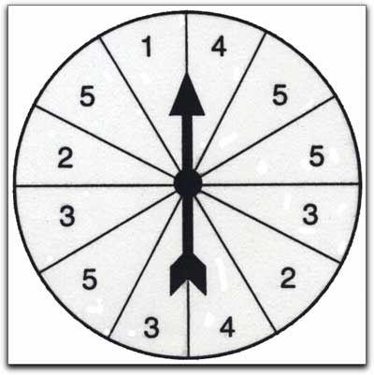

17. Find ***P(1)***

18. Find

19. Find

20. Find the probability that the spinner lands on an odd number or a number greater than 5.