Unit 5 Study Guide | Name ________________________ S ____
1. Which information is needed to show that a parallelogram is a rectangle?  A. The diagonals bisect each other.  B. The diagonals are congruent.  C. The diagonals are congruent and perpendicular.  D. The diagonals bisect each other and are perpendicular. |  | 2. Using A-D from #1, which information is needed to prove a parallelogram?
3. Given the points $P(2,-1) \& Q(-9,-6)$, what are the coordinates of the point on the directed line segment $\overline{PQ}$ that partitions $\overline{PQ}$ into the ratio $\frac{3}{2}$?  A. $\left(-\frac{23}{5},-4\right)$  B. $\left(-\frac{12}{5}. -3\right)$  C. $\left(\frac{5}{3},\frac{8}{3}\right)$  D. $\left(-\frac{5}{3},-\frac{8}{3}\right)$ | 4. An equation of a line a is $y=-\frac{1}{2}x-2.$ See graph.  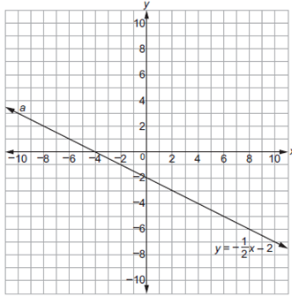  What is the equation of the line that is perpendicular to line a shown on the graph and passes through point $(-4,0)$.  A. $y=-\frac{1}{2}x+2$  B. $y=-\frac{1}{2}x+8$  C. $y=2x-2$  D. $y=2x+8$
5. Which point is on a circle with a center of $(3,-9)$ and a radius of 5?  A. $(-6, 5)$  B. $(-1, 6)$  C. $(1, 6)$  D. $(6,-5)$ | 6. Parallelogram ABCD has vertices as shown.  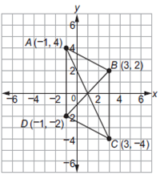  Write out the two sets, AC & BD, of the full distance formulas set equal to each other that would be used to prove that the diagonals of ABCD bisect each other? Then solve.

Use the information provided to write the standard form of a circle.
7. $Center: \left(2\sqrt{3}, -5\sqrt{2}\right), Radius=\sqrt{13}$ | 8. $Center: (4,-14)$ and the point $(6, 11)$ that lies on the circle.
Use the information provided to write the general conic form of a circle.
9. ${\left(x+10\right)}^{2}+{\left(y-7\right)}^{2}=9$ | 10. ${\left(x-14\right)}^{2}+{\left(y+14\right)}^{2}=9$
Use the information provided to write the standard form of a circle. Then idenify the center and radius length.
11. $x^{2}+y^{2}-20x+2y+76=0$ | 12. $2x^{2}+{2y}^{2}+28x+24y+21=0$
Find the center and the radius length to write the standard form of each circle.
13.  ______________________________  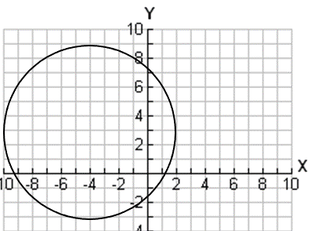 | 14.  _______________________________  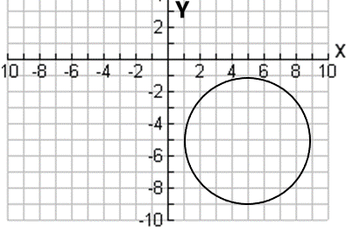

15. Prove or disprove that the points $A(8, 6), B(8, -6) and C(-10, 0$) are the vertices of an isosceles triangle inscribed in the circle centered at the origin Q and passing through the point $P\left(3, \sqrt{91}\right).$

On a coordinate plane, a local television station is located at the origin and has a broadcast range of 50 miles.
16) Write an equation that represents the region covered by this television station. | 17) Can a person who lives 18 miles to the East and 35 miles North of the station watch this TV station?
You’re a city planner, so you know that streets run north to south and avenues run east to west. Your friend Melissa lives at the corner of 3rd Street and 28th Avenue. Her sister Rebecca lives at the corner of 27th Street and 16th Avenue. If necessary, draw a graph to find the cross street that meets each criteria.
18. Is halfway between their homes. | 19. Is $\frac{2}{3}$ of the way from Melissa's to Rebecca's.
20. From Melissa’s home to Rebecca’s home by a ratio of $3:1$. | 21. From Melissa’s home to Rebecca’s home by a $\frac{1}{5}$ ratio.
Determine if point A lies on a circle with center C and point P which is known to lie on the circle.
22. $A( 5, 0), C(0, 0), P(3, 4)$ | 23. $A\left(0,4\right), C\left(2, 1\right), P(5, 3)$

For each figure using, prove the type of quadrilateral, using distance and, or slope. Keep diagonals in mind.
24. $ABCD: A(1, 2), B (2, 5), C (4, 3), D (5, 6)$ | 25. $EFGH: E (4,1), F(-2,3), G(2,-5), H(-4,-3)$
Write the equation of the lines below in slope-intercept form: y = mx + b.
26. Through $(-4, 5)$ and parallel to $y=-\frac{3}{2}x-5.$ | 27. Through $(4,1)$ and perpendicular to $y=-2x-2$
Find the area and perimater of the following triangle. Simplest form required. Reminder: Draw altitude to find height.
28. Area = _______  29. Perimeter = ________________ | 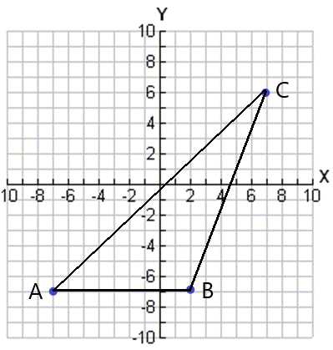
19) When proving a rectangle is a parallelogram, which method is the best choice?  Show that the diagonals bisect by finding the midpoint of both diagonals.  Show that the diagonals have the same length using the distance formula or the Pythagorean Formula. | 20) When proving the parent parallelogram, which method is the best choice?  Show that the diagonals bisect by finding the midpoint of both diagonals.  Show that the diagonals have the same length using the distance formula or the Pythagorean Formula.

