Name: ____________________________________________________________ Date: ________________________

**Unit 2A – Study Guide**

**Find the solution of the linear system graphically. Write your solution in the blank provided.**

**_______**1.  _______2.

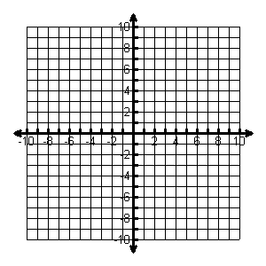 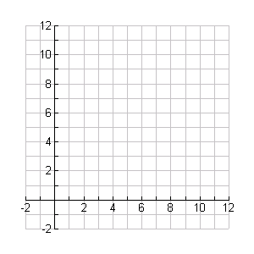

**Use substitution to solve the linear system. SHOW ALL WORK.**

________3.  _______4.

**a) (-4/3, -2/4)**

**b) (-2, -2)**

**c) (-2/3, 10/3)**

**d) (2, -2)**

**Use elimination to solve the linear system. SHOW ALL WORK.**

________5.  _______6.

**a) (1, -2)**

**b) (2, -1)**

**c) (1, 2)**

**d) (-2, 1)**

**7.** A store sold 32 pairs of jeans for a total of $1050. Brand A sold for $30 per pair and Brand B sold for $35 per pair. How many of Brand A were sold?

**a) 12 b) 16 c) 14 d) 18**

**8.** You are selling tickets for a basketball game. Student tickets cost $3 and general admission tickets cost $5. You sell 350 tickets and collect $1450. How many of each type of ticket did you sell?

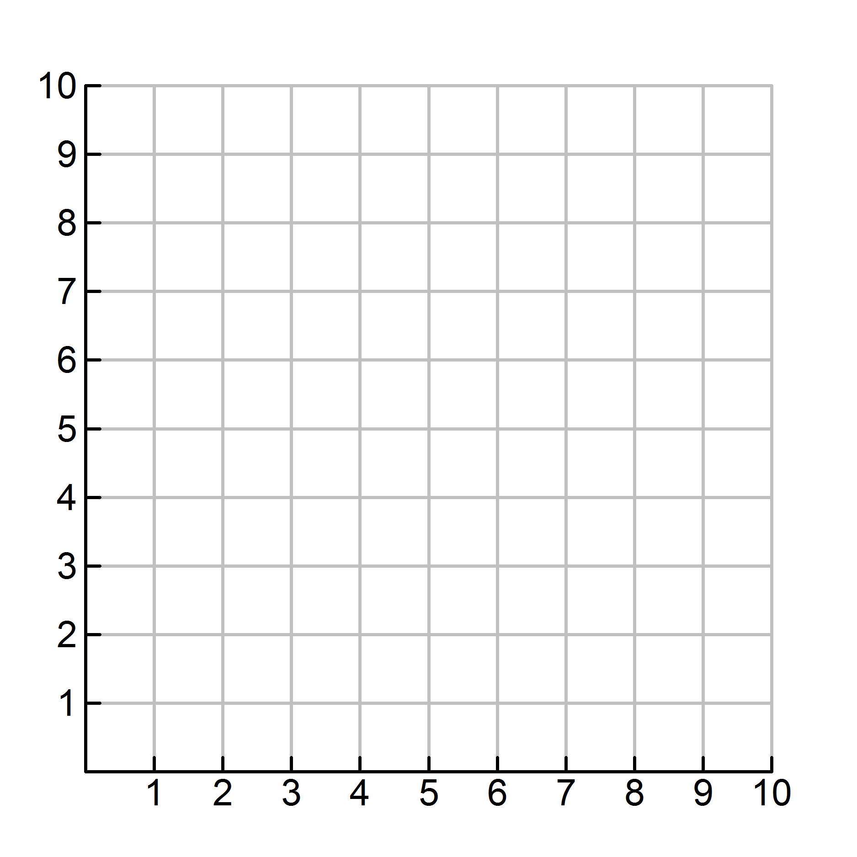**9.** You are looking to buy a bouquet of flowers for your favorite math teacher. Lilies cost $3.00 each and roses cost $4.00 each. You have budgeted *no more than* $28 to spend on flowers. Graph a linear inequality to illustrate how many of each type of flower you can purchase.

|  |  |
| --- | --- |
| **Equation** | **Steps** |
| $$2\left(4x+30\right)=76$$ | Original Equation |
|  |  |
|  |  |
|  |  |

**10.** **Solve the equation and write the reason for each step in solving the equation.**

**11.** Create and solve the inequality. Then, graph the solution on the given number line.

“5 more than 2 times a number is greater than 21”

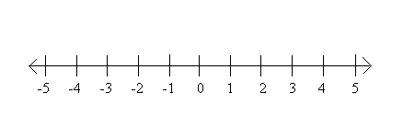

**Solve the literal equation for the indicated variable**  
**12**. $\frac{2}{5}x$– y = z, for **x**

**13**. $\frac{4a+b }{3}$ = c, for **a**

**a) $a=\frac{3b-c}{4}$**  **b) $a=\frac{4c+b}{3}$**  **c) $a=\frac{3c-b}{4}$** **d) $a=3b-c$**

**14**. You have $20 to spend. You need to buy chips and salsa for your friends. Chips cost $1 per bag and salsa costs $2 per jar.

a. Write the standard form equation. *Let x represent chips and y represent salsa*.

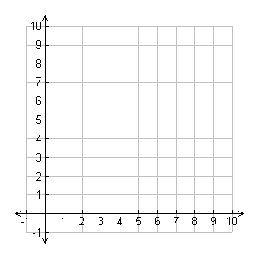b. Rewrite your equation in slope-intercept form and graph. *Label your x and y axes*.

c. If I buy 6 bags of chips how many jars of salsa can I buy?

**15.** Given the equation 2x + 3y = 12, identify the slope once the equation is put into slope-intercept form.

**a) $-\frac{2}{3}$ b) $\frac{3}{2}$ c) $-\frac{3}{2}$ d)** 4

**16.** Which property appropriately justifies the missing step?

|  |  |
| --- | --- |
| **Equation** | **Steps** |
| 3k - 5 = 7 | Original Equation |
| 3k = 12 | **?** |
| k = 4 | Division Property of Equality |

**17.** Write a linear equation to model the situation:*A cell phone plan costs $50 and $0.50 per minute.*

**18.** What is the solution to the inequality $5x-15 ≥2x+6$?

**19.** The formula *d=rt* tells the distance traveled at a given rate and time. *Solve the equation for t*. A car drove 100 miles at a rate of 20 miles per hour. *For how many hours was the car driving?*

**20.** Explain the ways you can determine if a system of equations will have (by graphing *and* solving algebraically):

1. Infinitely many solutions
2. No solution