|  |  |  |
| --- | --- | --- |
| **Unit 2 Test Part 1 Study Guide** | **Name _________________________________ S _____** | |
| 1. Which theorems or rule are used to prove that two triangles are congruent? | | |
| 2. Consider the triangles shown. Which rule, if any, can used to prove triangle congruency? | | |
| 3. If $m∠1=x+7, m∠2=2\left(x+2\right),$ and $m∠4=2(x+13)$ in the diagram below, find $m∠4$. | | |
| 4. In the diagram below $m∠ 2=5\left(x+1\right)$, $m∠3=40°$, and $m∠4=3(x+5)$. Find x and the measure of each angle. | | |
| **5.** Find $m∠3$ if $m∠1=3x+1$ and $m∠2=2(x+7)$. | | **6.** Find m<1 if m<2 = 5x and m<3 = 6x – 7. |

|  |
| --- |
| 7. $∆PQR$ and $∆STU$ are congruent triangles. Using this information, list the corresponding sides and corresponding angles. |
| 8. For ΔEFG and ΔMNP, it is known that $\overline{EG}≅\overline{MP}$, <G<P, and $\overline{FG}≅\overline{NP}$. Determine if the triangles are congruent, and if so, by which type of congruency.   1. SSS c. ASA 2. SAS D. It cannot be determined if the triangles are congruent. |
| 9. In this diagram, $\overline{CD}$ is the perpendicular bisector of $\overline{AB}.$ The two-column proof shows that $\overline{AC}$ is congruent to $\overline{BC}$. Fill in the missing pieces of the proof.     |  |  |  | | --- | --- | --- | | **Step** | **Statement** | **Reason** | | 1 | $\overline{CD}$ is the perpendicular bisector of $\overline{AB}$ | Given | | 2 | $$\overline{AD}≅\overline{BD}$$ | Definition of bisector | | 3 |  |  | | 4 |  | Definition of perpendicular lines | | 5 | $$∠ADC≅∠BDC$$ | All right angles are congruent | | 6 |  |  | | 7 | $$\overline{AC}≅\overline{BC}$$ |  | |
| **10. Given: $\overline{NO}∥\overline{MP}$**  and $\overline{MN}∥\overline{OP}$ **Prove:**   |  |  |  | | --- | --- | --- | | **Steps** | **Statements** | **Reasons** | | 1 | $\overline{NO}∥\overline{MP}$ and |  | | 2 |  |  | | 3 |  |  | | 4 |  |  | | 5 |  |  | | 6 |  |  | |
| **11. Given:** E is the midpoint of $\overline{AC} and \overline{DB}$ **Prove:**   |  |  |  | | --- | --- | --- | | **Steps** | **Statements** | **Reasons** | | 1 |  | Given | | 2 |  |  | | 3 |  |  | | 4 |  |  | | 5 |  |  | |
| **12. $∆DEF$**  and $∆TUV$ are congruent triangles. Which statement is known to be true?  a. $\overline{DE}≅\overline{TU}$ c. $\overline{DF}≅\overline{UV}$   b. $\overline{DF}≅\overline{TU}$ d. $\overline{DE}≅\overline{TV}$ |
| 13. For $∆ABC$ and $∆DEF$, the following is given: $∠C≅∠F$, $\overline{AB}≅\overline{DE}$, and $\overline{BC}≅\overline{EF}$. By which triangle congruence statement can it be concluded that the triangles are congruent?  a. SSS c. ASA  b. SAS d. It cannot be determined if the triangles are congruent. |
| 14. ΔUVW and ΔXYZ are congruent triangles. Which statement is known to be true?   1. <U  <V c. <V <X 2. <W <X d. <V <Y |

|  |
| --- |
| 15. Name all angles for each description.  Corresponding_____________________  Alternate Interior___________________  Alternate Exterior__________________  Vertical__________________________  Same side interior__________________ |

|  |
| --- |
| 16. Identify all angle measures. |

**Congruent Triangles**

17. Determine whether each pair of triangles is congruent. If so, write a congruence statement, and explain why the triangles are congruent.

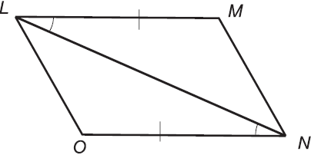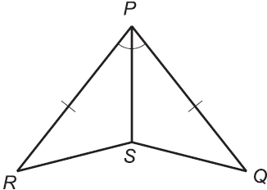 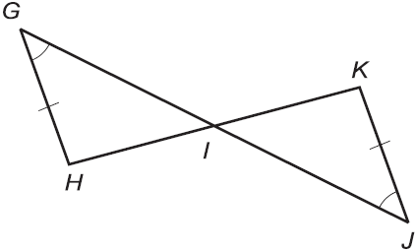

18. For ∆ABC and ∆DEF the following is given: $∠A≅∠D, ∠B≅∠E , \overline{AB}≅\overline{DE}$. Sketch a picture to determine if the two triangles can be proven congruent. If so, create a two column proof.

**Theorems about Lines and Angles**

19. Name the relationship and then find the missing angle measures by solving for x.

1. b.

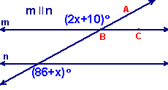 

c. d.

