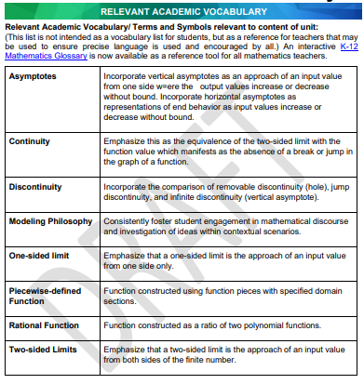

Link to mathematics glossary, please note not all words will be found in this resource.

