Proof Properties / Theorems / Reasons
- Given The first statement(s) you already know because the problem told you.

- Reflexive Property of Equality $a=a$
- Symmetric Property of Equality If $a=b$, then $b=a$.
- Transitive Property of Equality If $a=b$ and $b=c$, then $a=c$.
- Addition Property of Equality If $a=b$, then $a+c =b+c$.
- Subtraction Property of Equality If $a=b$, then $a-c=b-c$.
- Multiplication Property of Equality If $a=b$, then $a⋅c = b⋅c$.
- Division Property of Equality If $a=b$ and $c ≠ 0$, then $\frac{a}{c}=\frac{b}{c}$.
- Substitution If $a=b$, then $a$ may be substituted for $b$ anywhere it appears.
- Simplify When you do very simple math like when combining terms.

- Reflexive Property of Congruence $A$$A$
- Symmetric Property of Congruence If $A$$B$, then $B$$A$.
- Transitive Property of Congruence If $A$$B$ and $B$$C$, then $A$$C$.

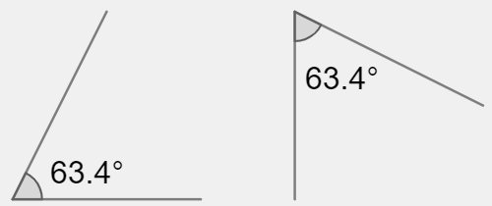
- Defn. of Congruent Angles Angles are congruent if and only if they are equal in measure.
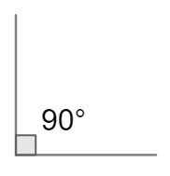
- Defn. of Right Angle Right angles are angles with a measure of $90^{∘}$.
- Defn. of Perpendicular Two lines are perpendicular if they intersect at a right angle.
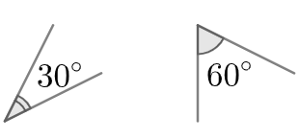
- Defn. of Complementary Angle Two angles that add up to $90^{∘}$. ($m∠A + m∠B =90^{∘}$)
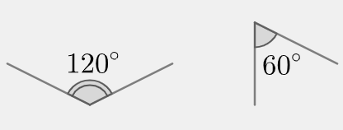
- Defn. of Supplementary Angle Two angles that add up to $180^{∘}$. ($m∠A + m∠B=180^{∘}$)
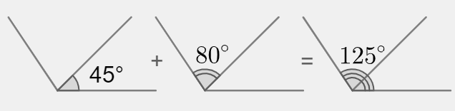
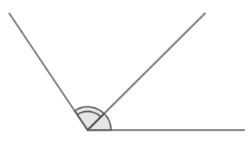
- Defn. of Adjacent Angle A pair of angles which only share one side and do not overlap.
- Angle Addition Postulate If B is in the interior of $∠ADC$, then $m∠ADB+m∠BDC=m∠ADC$.
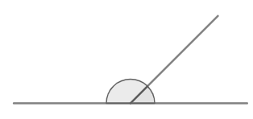
- Defn. of Linear Pair A pair of adjacent angles that form a straight line when combined.
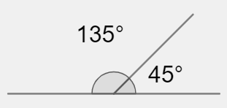
- Linear Pair Postulate Linear pair angles are supplementary.
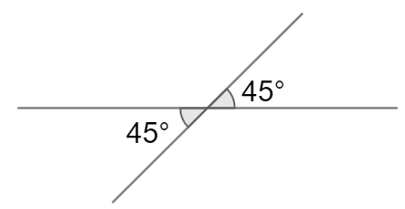
- Vertical Angle Theorem (VAT) Vertical angles are congruent.
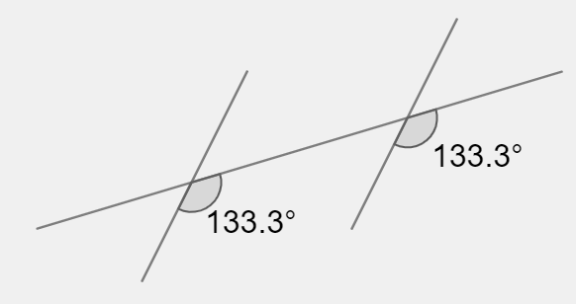
- Corresponding Angles Postulate Corresponding angles on parallel lines are congruent..
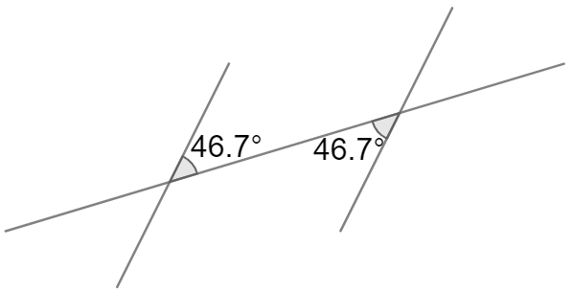
- Alternate Interior Angles Theorem Alternate interior angles on parallel lines are congruent.
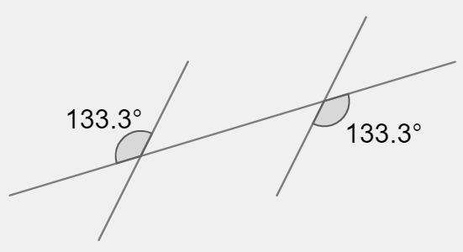
- Alternate Exterior Angles Theorem Alternate exterior angles on parallel lines are congruent.
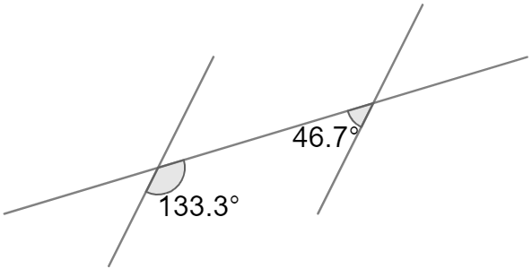
- Consecutive Interior Angles Theorem Consecutive interior angles on parallel lines are supplementary..
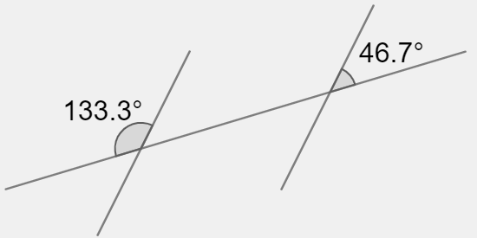
- Consecutive Exterior Angles Theorem Consecutive exterior angles on parallel lines are supplementary.
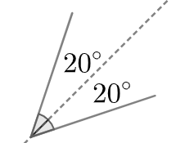
- Defn. of Angle Bisector A line that bisects an angle, divides it into two congruent halves.
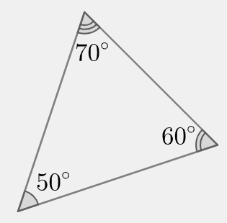
- Triangle Angle Sum Theorem The sum of all the interior angles of a triangle is $180^{∘}$.
- Defn. of Congruent Segments Segments are congruent if and only if they are equal in length.
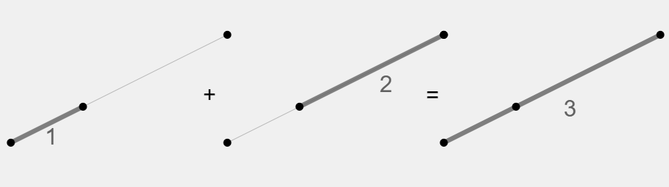
- Segment Addition Postulate If $B$is on $\underline{AC}$, then $AB+BC=AC$.
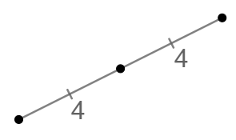
- Defn. of Midpoint If $B$ is the midpoint of $\underline{AC}$, then $\underline{AB }$$\underline{BC}$.
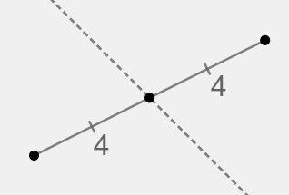
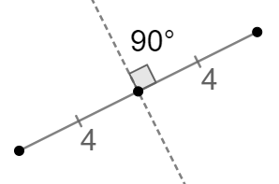
- Defn. of Segment Bisector A line that bisects a segment, divides it into two congruent halves.
- Defn. of Perpendicular Bisector A perpendicular line that bisects a segment at a right angle.
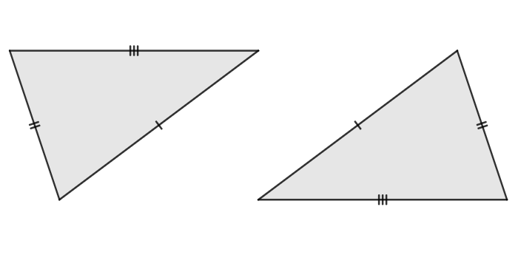
- SSS Triangle Congruence Theorem Triangles are congruent if all three corresponding sides are congruent.
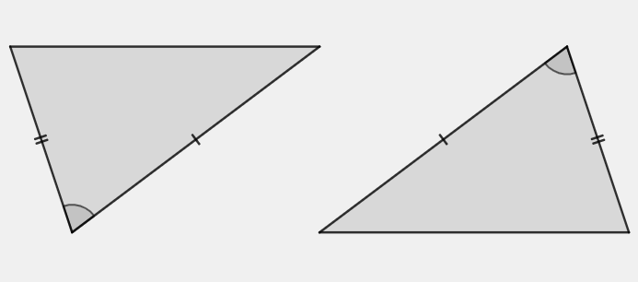
- SAS Triangle Congruence Theorem Triangles are congruent if two corresponding sides are congruent and
their included angles are congruent.
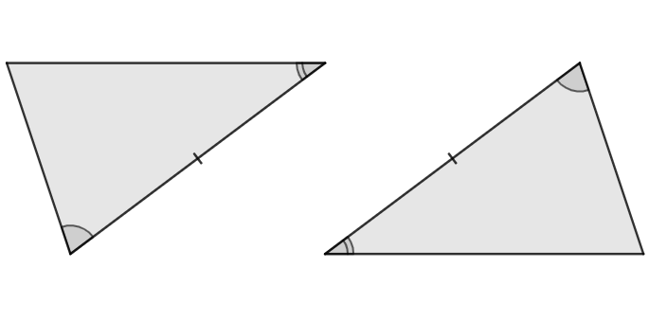
- ASA Triangle Congruence Theorem Triangles are congruent if two corresponding angles are congruent and
their included sides are congruent.
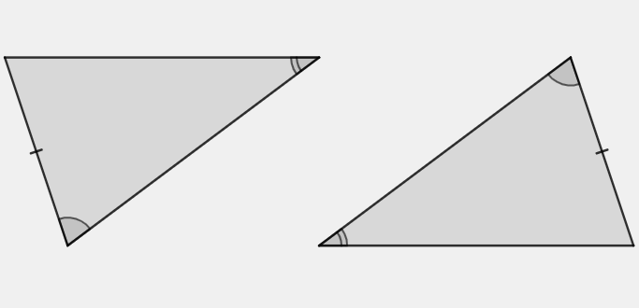
- AAS Triangle Congruence Theorem Triangles are congruent if two corresponding angles are congruent and
one pair of corresponding non-included sides are congruent.
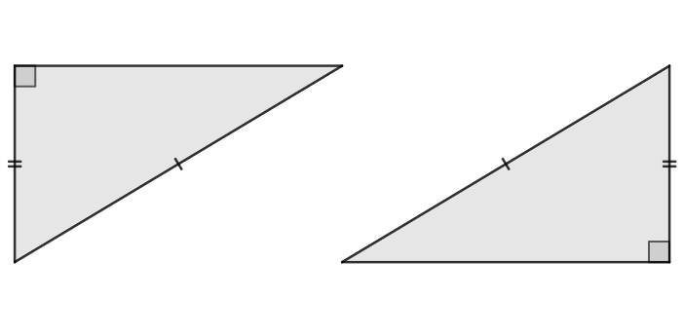
- HL Triangle Congruence Theorem Right triangles are congruent if the hypotenuse of each is congruent
and one of the corresponding legs is congruent.
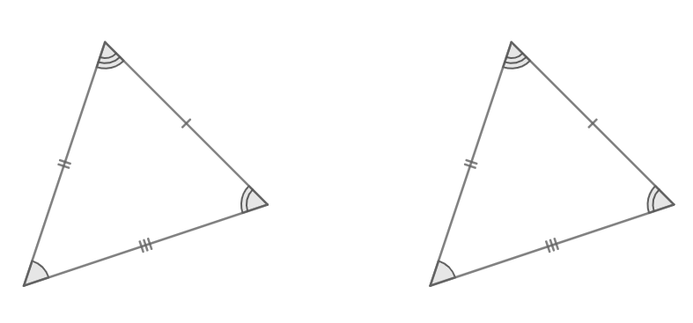
- Corresponding Parts of Congruent If two triangles are congruent, then all their corresponding parts are
Triangles are Congruent (CPCTC) congruent as well.
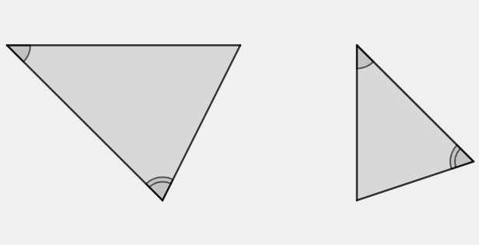
- AA Triangle Similarity Theorem Triangles are similar if two corresponding angles are congruent.
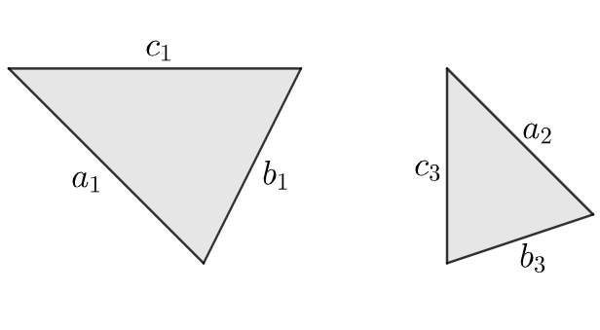
- SSS Triangle Similarity Theorem Triangles are similar if three corresponding sides are proportional.
$\frac{a_{1}}{a_{2}}=\frac{b_{1}}{b_{2}}=\frac{c_{1}}{c_{2}}$
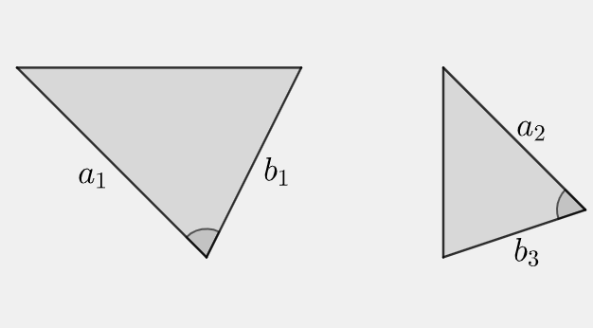
- SAS Triangle Similarity Theorem Triangles are similar if two corresponding sides are proportional and
their included angles are congruent.
$\frac{a_{1}}{a_{2}}=\frac{b_{1}}{b_{2}}$

