Vocabulary
Identity –
Assosciated –
Expression –
Exceptional –
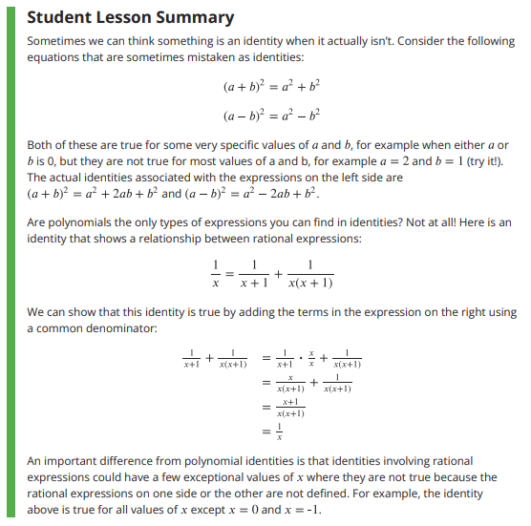

Title: ________________________________________________________________

1 to 3 sentence summary of the article:

Try these!

