1) Write the equation for the graph.  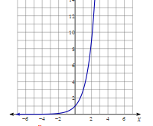 | 2) Write the equation for the graph.  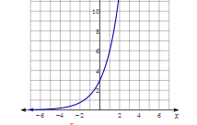
3) Write the equation for the graph.  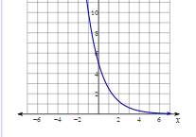 | 4) What are the ordered pairs for x = -2, x = 0, x = 1. 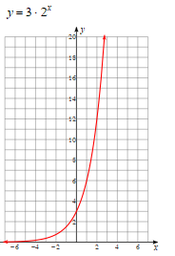
5) Write the equation for the exponential graph using the following ordered pairs.  A ( -1, 9) B (0, 4) C ( 1, 2). | 6) Write the equation for the exponential graph using the following ordered pairs.  A ( 1, 12) B ( 2, 36) C ( 3, 108)
