Opening

Find the EB of the following:

EB is not always infinite or negative infinity…now that we have rational functions.

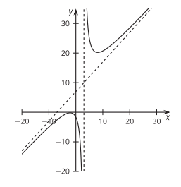
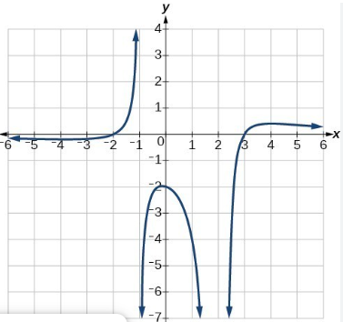

Closing

Find the EB, HA, and VA of the following:

