Linear graph  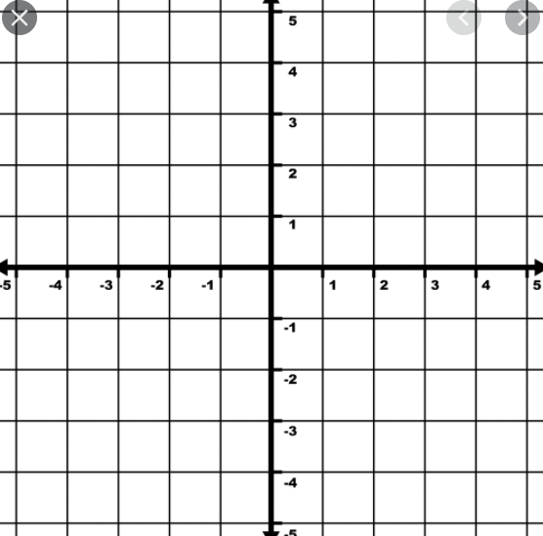 | Negative linear graph
Quadratic graph | Negative quadratic graph
Cubic graph | Negative cubic graph
Quartic graph | Negative quartic graph
Quintic graph | Negative quintic graph
Root | Factor
Multiplicity | Complex conjugate pair

Note:A polynomial is just made up of factors and/or a series to linear terms which are typically multiplied to make it ‘look’ hard.

