There will be constructions on the Geometry EOC. Below you will find several Geometry EOC style questions. The question numbers are NOT in order, as the problems were gathered from various sources. Please chose the correct answer.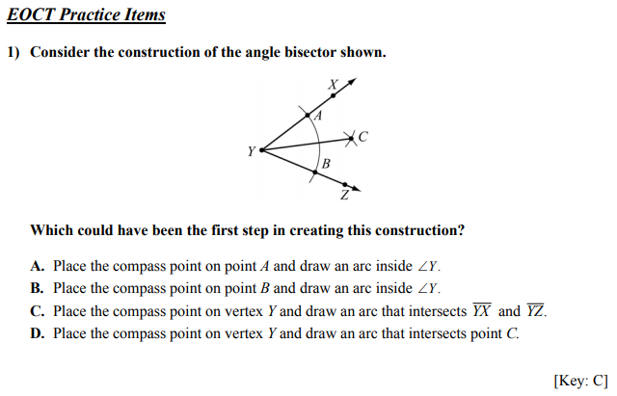 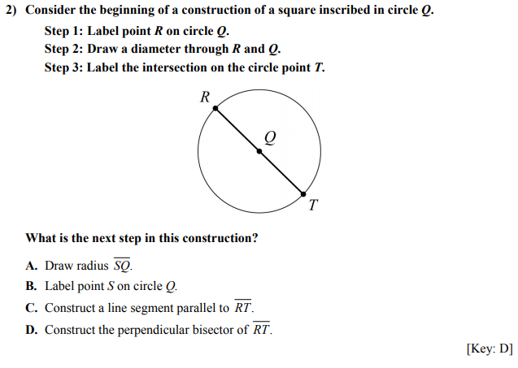
4)
