Algebra 1 ~ Day 2, 10/3/2017 Unit 4 Practice Quiz Name ________________________

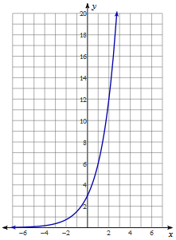
- Use the given graph to identify the characteristics.
Domain ___________
Range ___________
Asymptote _______
X-intercept _______
Y-intercept _______
End Behavior:
As $x→-∞, y→___$
As $x→∞, y→___$
Circle one:
Increasing or Decreasing
AROC [0, 1]:

~~~~~~~~~~~~~~~~~~~~~~~~~~~~~~~~~
- Use the given graph to identify the characteristics.
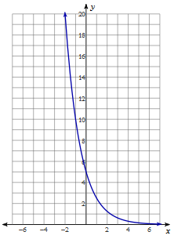
Domain __________
Range ___________
Asymptote _______
X-intercept _______
Y-intercept _______
End Behavior:
As $x→-∞, y→___$
As $x→∞, y→___$
Circle one:
Increasing or Decreasing
AROC [-1, 0]:

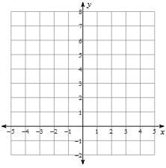
Fill in the table for each exponential function and then graph the function.
x | y
-3
-2
-1
0
1
2
3
- $f\left(x\right)={3(2)}^{x}$
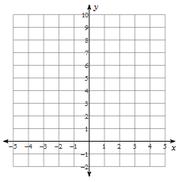
~~~~~~~~~~~~~~~~~~~~~~~~~~~~~~~~~
- $f\left(x\right)=5^{x}$

x | y
-3
-2
-1
0
1
2
3
~~~~~~~~~~~~~~~~~~~~~~~~~~~~~~~~~
- $f\left(x\right)={\left(\frac{1}{5}\right)}^{x}$
x | y
-3
-2
-1
0
1
2
3
Consider the parent function ${f\left(x\right)=\left(\frac{1}{2}\right)}^{x}$. How would the original graph be transformed if:

- ${f\left(x\right)=2\left(\frac{1}{2}\right)}^{x}$

- ${f\left(x\right)=\left(\frac{1}{2}\right)}^{x}-5$

- ${f\left(x\right)=\left(\frac{1}{2}\right)}^{x+4}$

- ${f\left(x\right)=-\left(\frac{1}{2}\right)}^{x}$

- ${f\left(x\right)=-\frac{1}{4}\left(\frac{1}{2}\right)}^{x-3}+5$

~~~~~~~~~~~~~~~~~~~~~~~~~~~~~~
Write an equation for the given graphs:

