Compare the graph of $\sqrt{3x}$
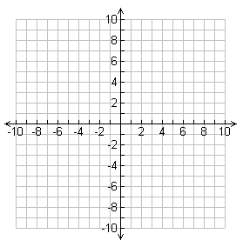
Identify the following key characteristics for the following graph:
Domain

Range

x-intercepts, roots, zeros, and solutions

y-intercepts

intervals of increase

interval of decrease

positive

negative

maximum

minimum

end behavior

Compare the graph of (3x)^{1/2} - 2
Identify the following key characteristics for the following graph:
Domain

Range

x-intercepts, roots, zeros, and solutions

y-intercepts

intervals of increase

interval of decrease

positive

negative

maximum

minimum

end behavior

