Please read the following instructions completely before starting!
The history
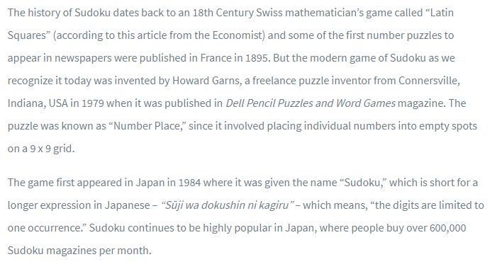
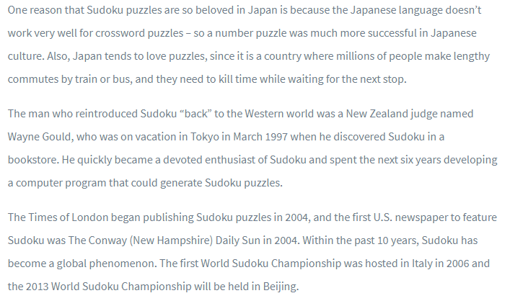
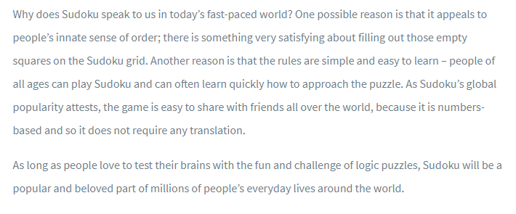
Please watch a video on strategies on how to play Sudoku and watch someone complete a puzzle.
https://www.youtube.com/watch?v=OtKxtvMUahA

Now to build your skills at Sudoku... Access the following online Sudoku practice and begin practicing. Unless you have played Sudoku, you will probably want to make sure the setting is on “easy.”
Access Sudoku at this link https://sudoku.com/

Try 3-5 ‘easy’ games. Adjust the setting to “medium” and try 3-5 more. Lastly, adjust the setting to “hard” and give this setting a try.

After you have practiced several Sudoku games, you will be deigning 2 easy, 1 moderate and 1 hard Sudoku puzzle for one of your classmates to solve. Remember that your Sudoku puzzles must be solvable, so give your puzzles some thought! Other students will provide you feedback to your Sudoku creation.

Try this easy Sudoku puzzle on paper Name __________________________

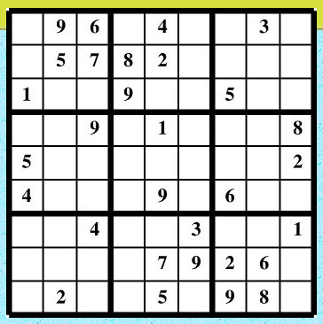

Try this medium Sudoku puzzle on paper Name __________________________

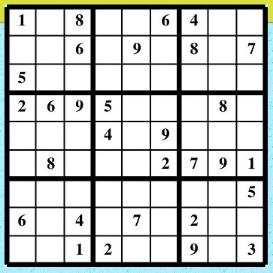
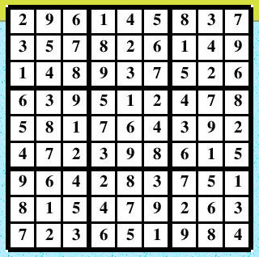
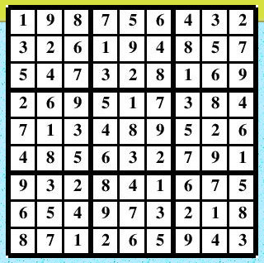

Name __________________________________
Date ______________________ Pd __________
“Easy” Suduko Design
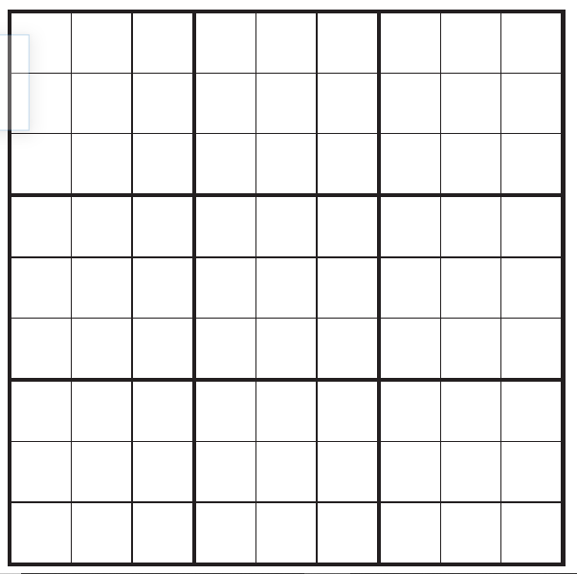

Name __________________________________
Date ______________________ Pd __________
“Easy” Suduko Design

Name __________________________________
Date ______________________ Pd __________
“Medium” Suduko Design

Name __________________________________
Date ______________________ Pd __________
“Hard” Suduko Design

Name __________________________________
Date ______________________ Pd __________
Please answer the following questions about Sudoku in complete sentences using correct punctuation.
1) Do you like Sudoku puzzles? Why or why not? _______________________________________________________________________________________________________________________________________________________________________________________________________________________________________________________________
2) Are Sudoku puzzles easier to solve online or on paper? Why?
_______________________________________________________________________________________________________________________________________________________________________________________________________________________________________________________________
3) How did your classmates do on your Sudoku designs? Were the puzzles solvable? Why or why not?
_______________________________________________________________________________________________________________________________________________________________________________________________________________________________________________________________
4) Do you have another ‘similar’ puzzle like Sudoku that you enjoy?
_______________________________________________________________________________________________________________________________________________________________________________________________________________________________________________________________
Make sure your solved puzzles are attached (Page 3 & Page 4) followed by the 2 easy puzzles, 1 medium puzzle and 1 hard puzzle are attached (Page 6, Page 7, Page 8, and Page 9). This page (Page 10) should be on the front of your puzzles to be turned in! Thank you! I hope you have enjoyed Sudoku!!

