Please read the entire project before you start. You will be completing a series of coding activities at code.org. I have opened a classroom which you will join.
Please sign in using the following instructions. PLEASE choose a display name that I will recognize (like your FIRST NAME and LAST INITAL). If I don’t recognize you, I will not be able to give you a grade.

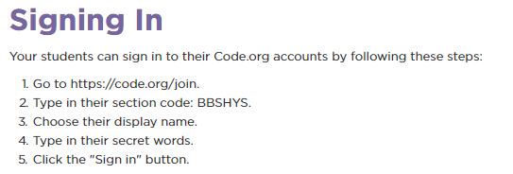
Make sure you sign in as a student, so you will be able to access the activities.
You will not see your name, yet because you have not created an account. To create an account:
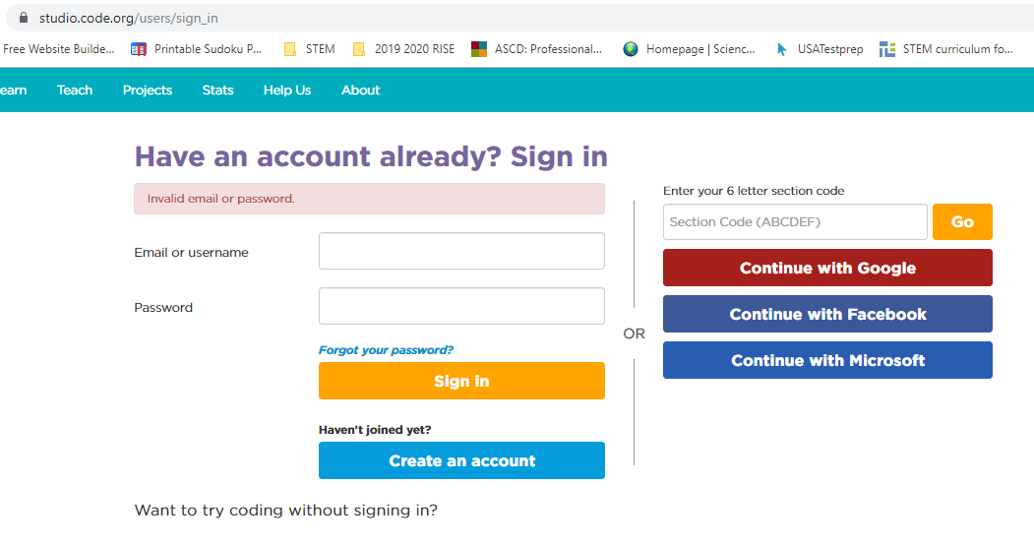

The following screen will open. Please complete as a student. Your email should be your school email. Your password should be your lunch number (if you use these, you are less likely to forget).

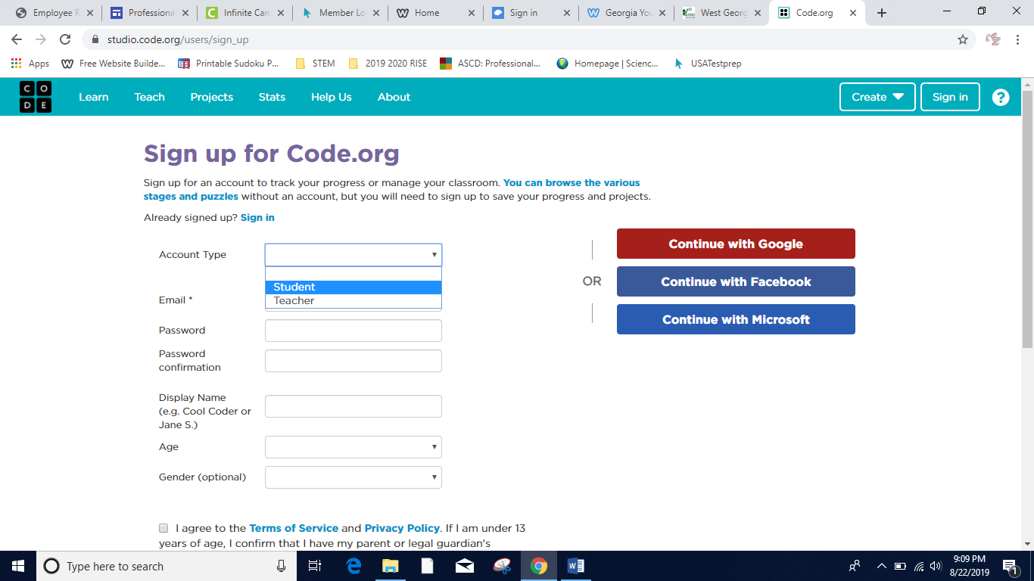

Once your account is created, you need to find Mrs. Cole’s course. Please enter the section code (BBSHYS) in the correct location.

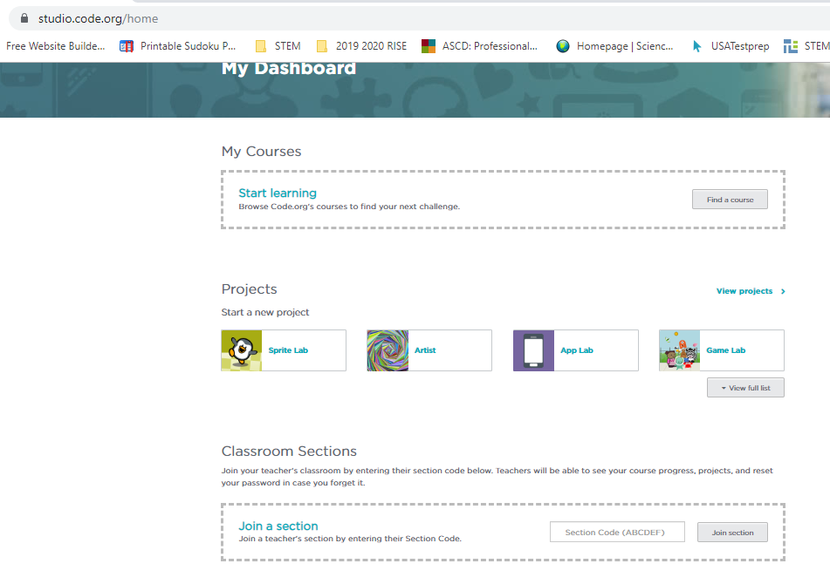

This is where you enter BBSHYS to
Enter Mrs. Cole’s course.

When you join the section correctly, you will see this confirmation. Hooray!
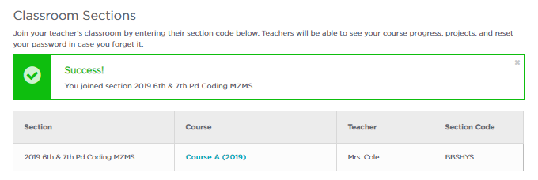
You are initially signed up for the first course (Lesson 1: Course A Going Places Safely & Lesson 2: Learn to Drag and Drop).
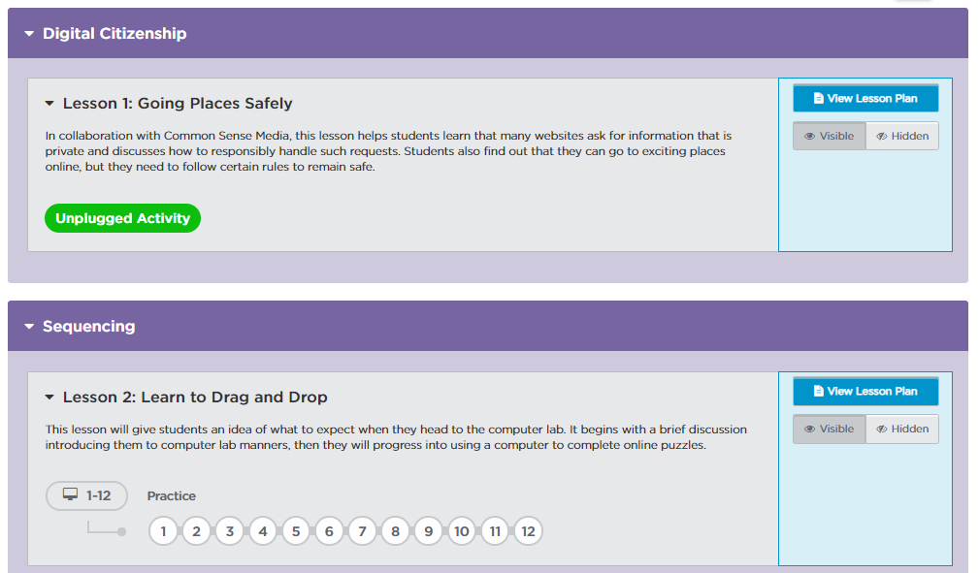

Soon additional coding courses will be unlocked and you will proceed probably in the following order:
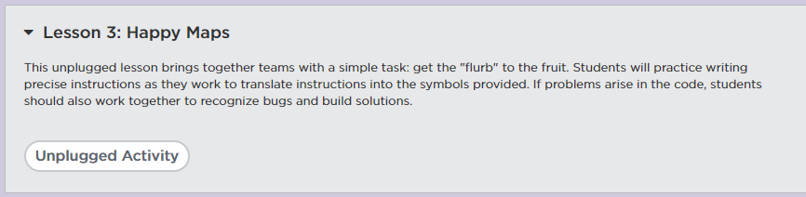

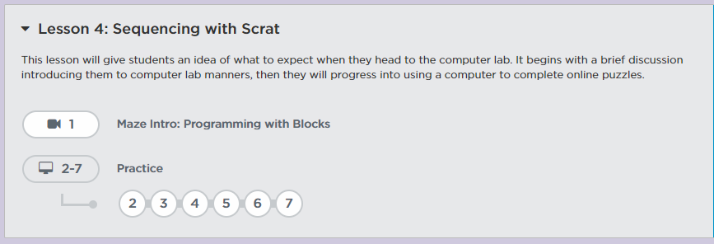

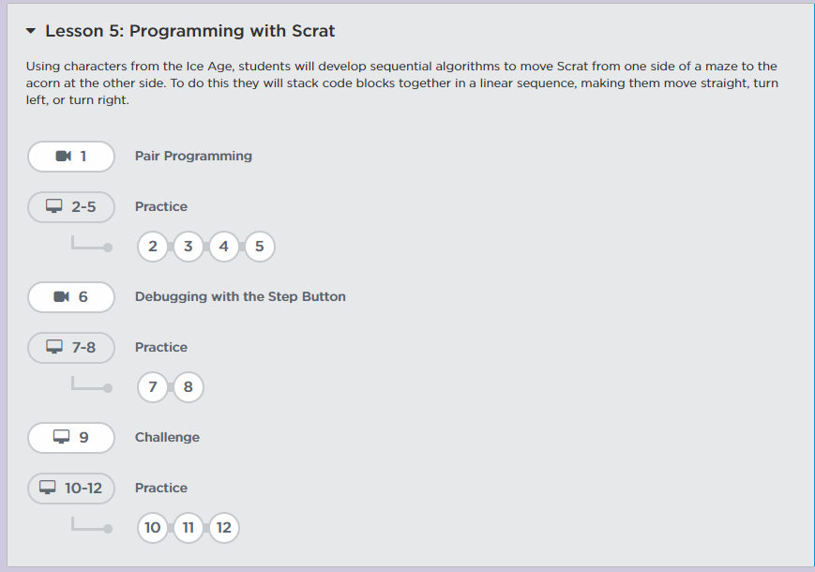

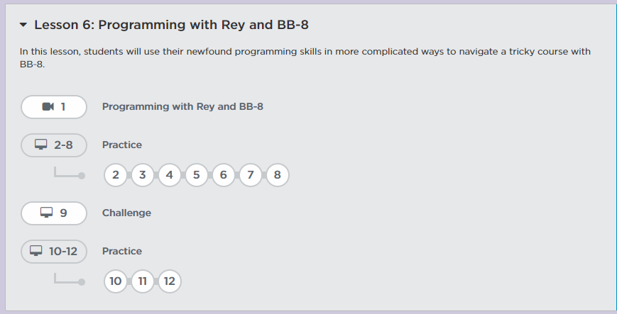

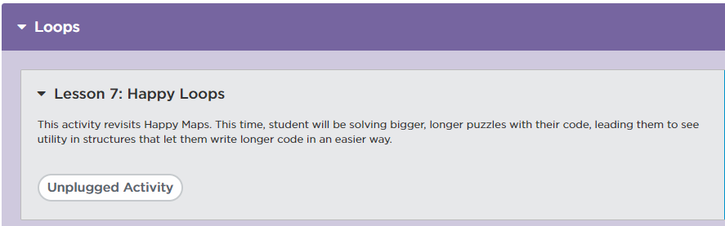

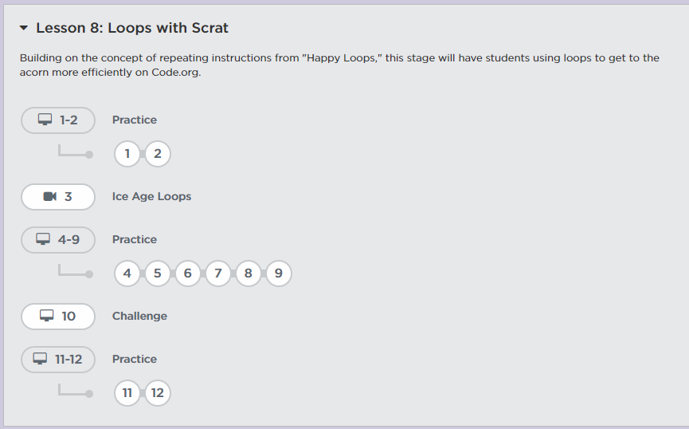

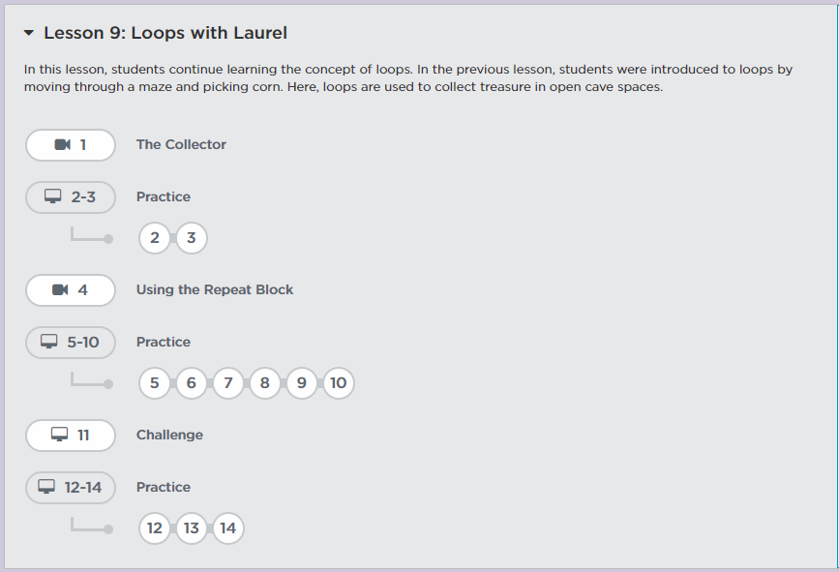
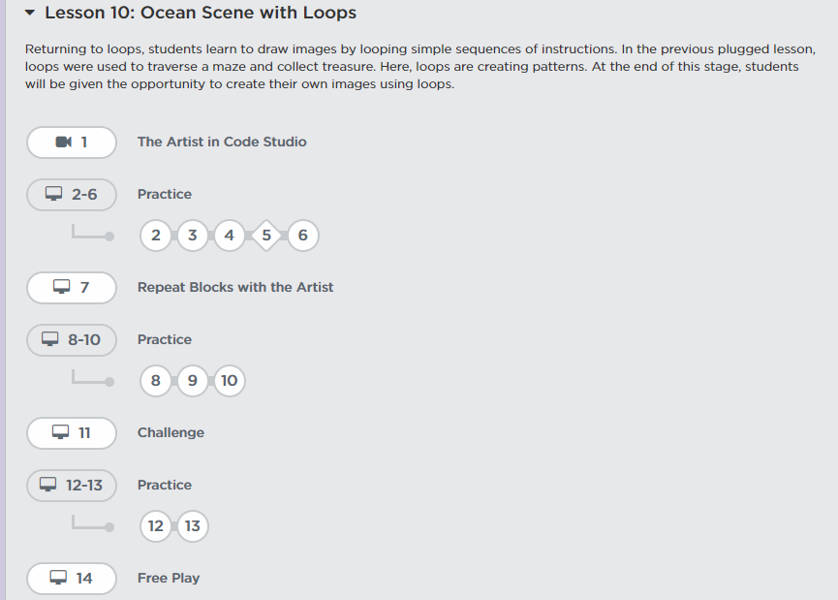
At the end of each lesson you will record the answer to the following question on a Word document which you will save to your laptop:
What did you learn from Lesson 1 Going Places Safely?
What did you learn from Lesson 2 Learn to Drag and Drop?
What did you learn form Lesson x _________________?

*You will continue to answer these questions, in complete sentences and using punctuation, as you complete each lesson. Please record your questions and responses in this Word document which you will submit to me a future date. Please keep this Word document up to date as you are completing lessons.

This coding activity will take many days! However, you are expected to make adequate daily progress. I can monitor your work within the coding platform, so please do your best and happy coding!

