Review the following ruler which has equivalent fractions.
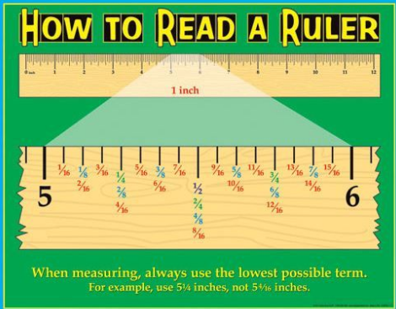
1) How many 1/2s are in an inch?
2) How many 1/4s are in an inch?
3) How many 1/8s are in an inch?
4) How many 1/16s are in an inch?
5) Which is lower terms 5-4/8 or 5 ½?
6) Which is a lower term 5-7/8 of 5-14/16?
We will review the following 2 examples (one of adding using a ruler and one of subtracting using a ruler) together.
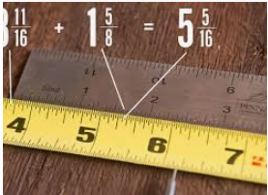
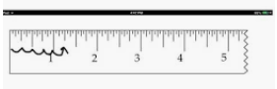
1-1/4 – 3/8 = 7/8

Use a ruler for assistance adding or subtracting the fractions:

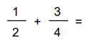
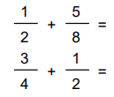
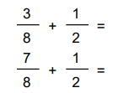
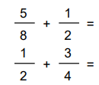
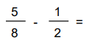
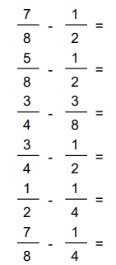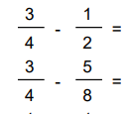

Use a ruler for assistance adding or subtracting the following fractions:
1
3

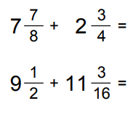
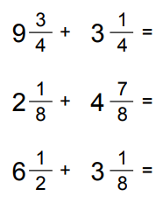
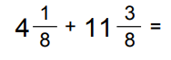
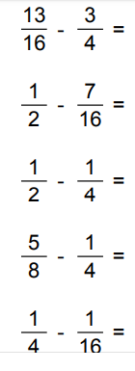
3
7
2
11
4
6
5
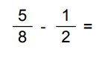
2
8

