Read this document thoroughly before you begin this project!
You will be working with 2 – 4 other peers.
Please view the following view: https://www.youtube.com/watch?v=JAufbnUR96U
The goal of this project will be to develop skills to use a tape measure or ruler. You and your team will take turns measure objects. You will compare answers. This comparison of answers will determine if you can read a tape measure.
Objects might include someone’s pencil, an eraser, the length of a notebook, an item you find in the classroom etc.
My 4 items and length are:
Items lengths I checked my measurement with
1)
2)
3)
4)
After each person checks their measurements on 4 different objects you will answer the following questions. You will not work on answering these questions until you have measured and checked answers of 4 objects.
Please answer in complete sentences.
1) What is the most important thing you must remember when using a tape measure in order to get the measurement correct?

2) Why are the ‘tick’ marks difference lengths on a tape measure? What do the different lengths represent?

3) Write down the fractions represented on a tape measure, there are 3 (one of them is 1/8)?
4) Place the fractions from question #3 in order from smallest fraction to largest fraction. If a ‘new’ and ‘smaller’ tick mark could be added what would the new fraction be?

5) If a contractor was measuring pieces of lumber for a hardwood floor and he measured one piece to be 12 ½ inches and the second piece to be 8 1/8. How long will the two pieces be when he places them together end-to-end on the hardwood floor?

6) What occupations do you know or think would use tape measures or rulers? List 2-3 occupations.

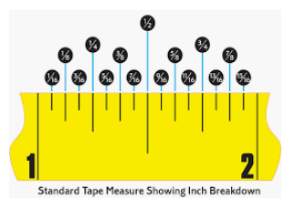
7) What is the measure of the tape measure on the left where the arrow is pointed?

8) What is the measurement of 1 + 3/8? Draw circle around the answer on the tape to the left.
9) What is the measurement of 1 ¼ + 5/16? Draw a square around the answer on the tape to the left.

10) A contractor has measure and cut a small piece of trim. The trim is 2 inches. His helper states the trim piece is too long by 1/4. Draw a triangle around the length the trim piece should be cut to on the tape to the left.

