Please read the entire document before you start!
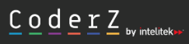
I am going to ask you to create an account in

using the following link: https://play.gocoderz.com:443/login/#/joinclass/frizzymoment

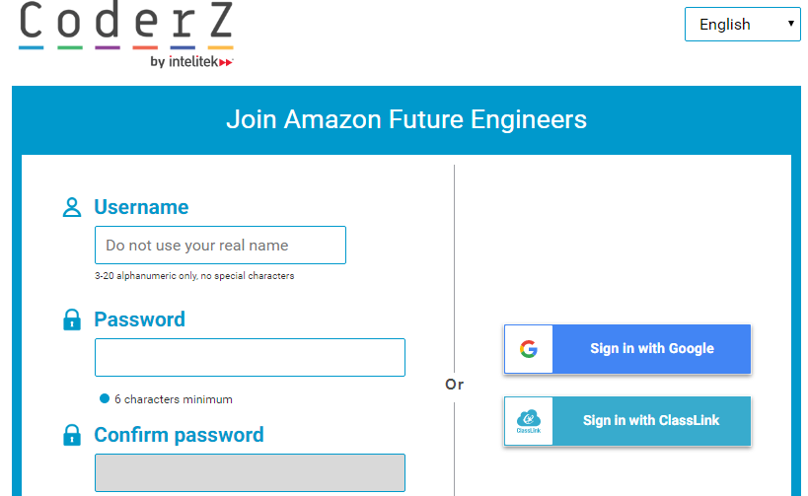

Once you enter the url you will see the screen to the left…it would be best if you use the “Sign in with Google” so you do not have to keep up with a username and password!!!

CoderZ will give you an opportunity to use your block programing skills as it guides you through “Adventure Peak.” I was able to program my robot to successfully make it through the entire course and all 7 activities….I did make some errors and my robot drove off the course, so I had to reset the simulation and re-work my block programming (more than once!). But, I did have fun! I hope you do too!
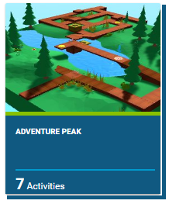
To get started…Adventure Peak is the first course you will complete. There are 7 activities that will help you build your skills in order to get your robot through the course.
When you are complete, please screen capture the Congratulation message at the end of the course and submit this to me, so I know you have successfully finished! The message says something like…congratulations on completing Adventure Peak. Lets have this finished by the end of this week!
We will have a check in or two this week in order to see your progress. Good luck block programming your robot!

