Name _________________________________________________
What is the pattern?? See if you can work with someone close to you in order to find the next two rows! Good luck!

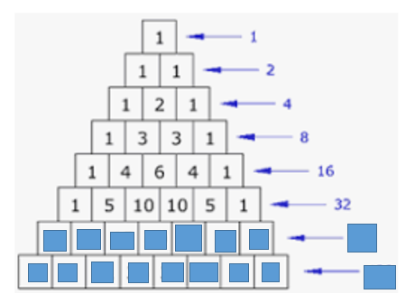

Over →

Name _________________________________________________
What is the pattern?? See if you can work with someone close to you in order to find the next two rows! Good luck!

Over →

Now it is your turn! Create a similar but different pattern.

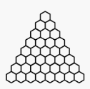

Now it is your turn! Create a similar but different pattern.

