Please read the following instructions completely before starting!
Many of you play video games outside of class, but do you play video games made using the program Scratch?
Today is your day to play Scratch video games which can be designed by students just like you!

Please go to Scratch and login, then Explore:
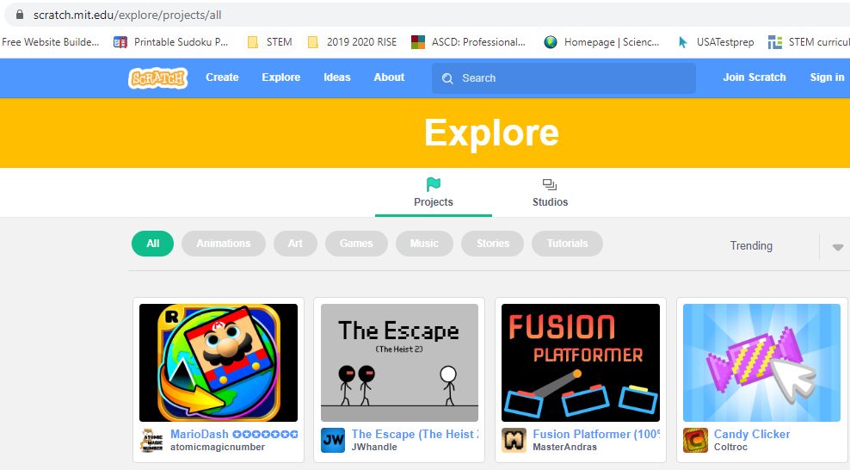
Once you select Explore, you will see many games. You can scroll through the various games or even search using Search which can be found on the top of the website.

Today you play a minimum of 6 games (you can do more)!

Please write on the paper, which you will turn in, the following for each game:
Name of the game:
How do you win:
One improvement you would suggest:
Interpret one block of code:

Note on the last topic: Interpret one block of code, you will use the ‘See inside’ feature of Scratch.

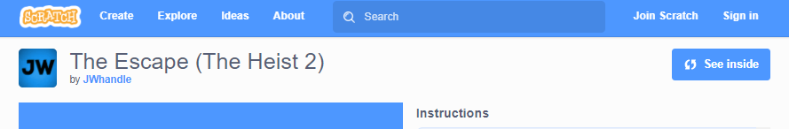

I used the game “The Escape” and the block of code I want to interpret is the following:
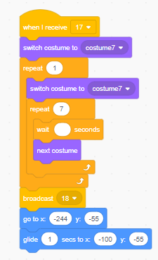
For the ‘Interpret one block of code’ I might put the following:
The Sprite changes to costume 7, this repeats until broadcast 18, then the Sprite moves to (-244, -55), and in 1 second glides to the location (-100, -55).

Please have fun with your minimum of 6 games and interpreting the code! Please don’t forget to turn your work in!

