Please read the entire document before you start.
Today, with your team of people at your table, you are going to design a ‘cup pyramid.’
You will have 6 cups, 1 rubber band, and several pieces of string. Once you have received all of your supplies, you will start a timer in order to document how long it takes your team to construct the pyramid.
Rules:
You may not ‘touch’ the cups with any part of your body
You may pick up a cup which has fallen off the table and place it ‘open side’ down on the table like this:
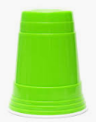

When you are done your team’s pyramid should look like this:
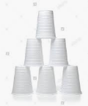
Stop the timer when your team has successfully placed the final cup on the pyramid.
Please answer the following questions after you complete your pyramid. Please discuss for a minimum of 1 minute with your groups before you answer the questions. You must write in complete sentences using proper capitalization and punctuation.
1) If you could change one thing to make this challenge easier what would it be and why?
2) If you could change one thing to make this challenge more difficult what would it be and why?
3) What is a ‘good’ number of people to have in a group for this challenge? Please state why you feel this number is good?
4) Where (outside) of school would you need a skill like you used with your team to create this pyramid? Please explain.
Please be ready to share your answers with the class. Also, these questions will be turned in!

Happy pyramid building!

