New Vocabulary

Exponential function –

Deciphering –

Phenomena –

Relevance –

Evident –

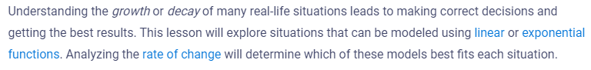

Title: ________________________________________________________________

1 to 3 sentence summary of the article:

