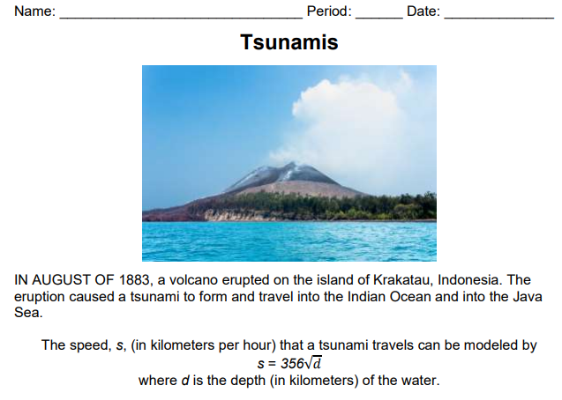
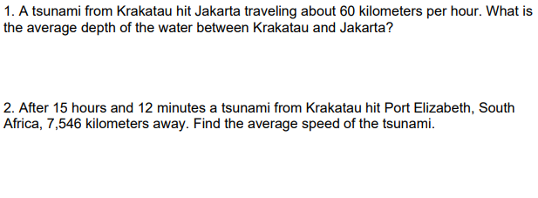
3. Based on this information, explain why or why not Tsunamis are dangerous. Think about Problem 1 and Problem 2, which Tsunami was more dangerous and why?

