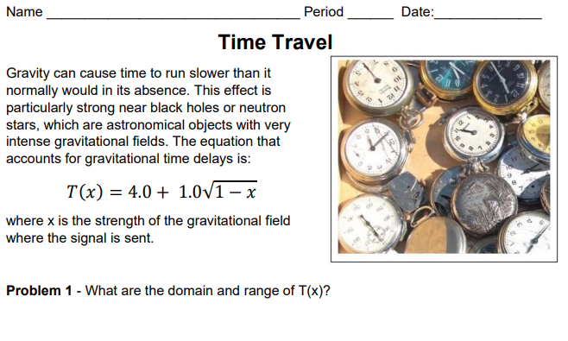
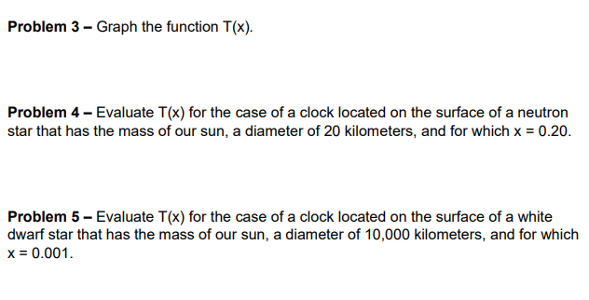
Problem 6 – Based on Problem 4 & Problem 5 does gravity have a large or small impact on time? Explain.

