Compare the graph of $-\sqrt{x}$
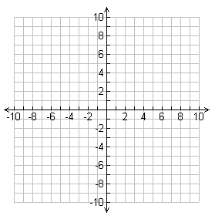
Identify the following key characteristics for the following graph:
Domain

Range

x-intercepts

y-intercepts

intervals of increase

interval of decrease

positive interval

negative interval

maximum

minimum

end behavior

Compare the graph of (x)^{1/3} - 1
Identify the following key characteristics for the following graph:
Domain

Range

x-intercepts

y-intercepts

intervals of increase

interval of decrease

positive interval

negative interval

maximum

minimum

end behavior

