New Vocabulary
Quadratic –
Trajectory –
Parabola/Parabolic –
Suspension –
Vertex –

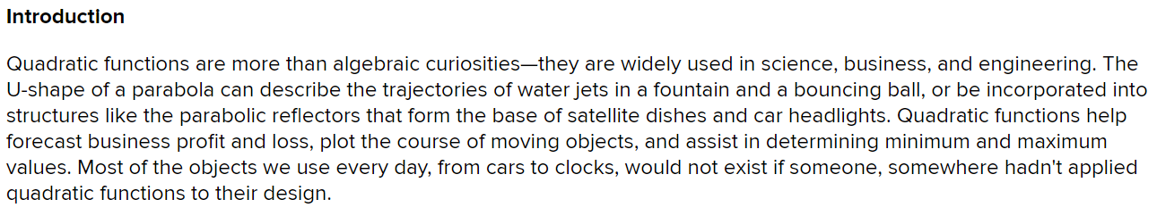
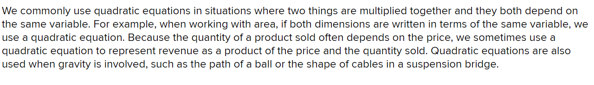
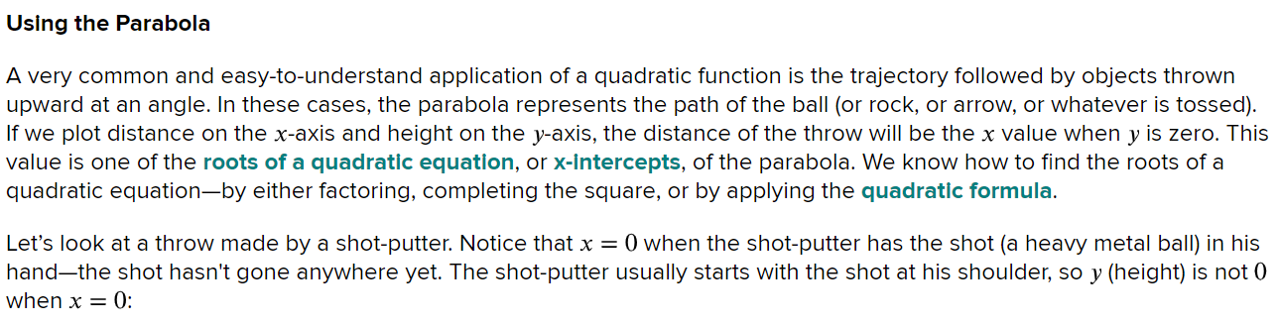
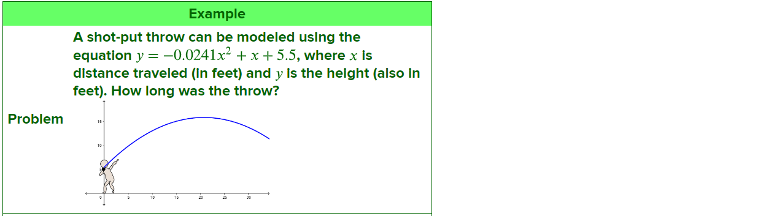

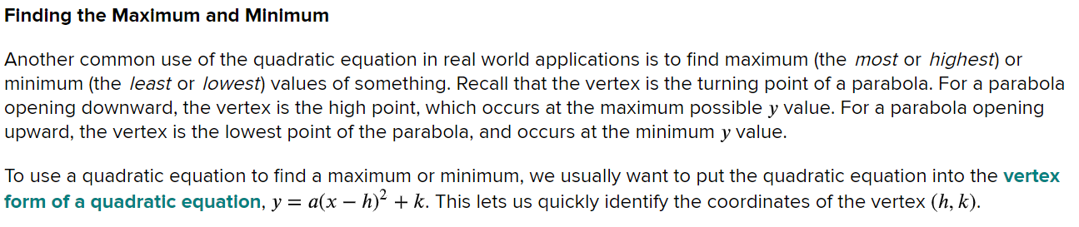
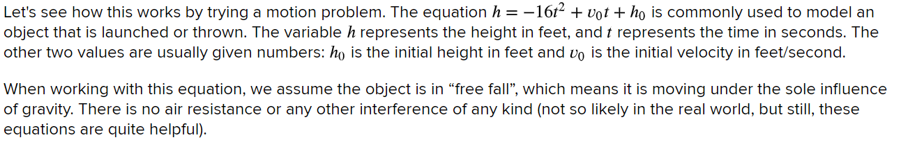
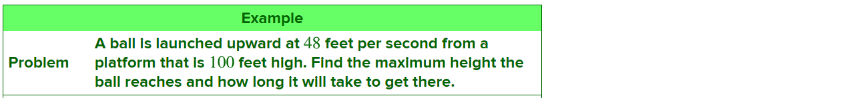
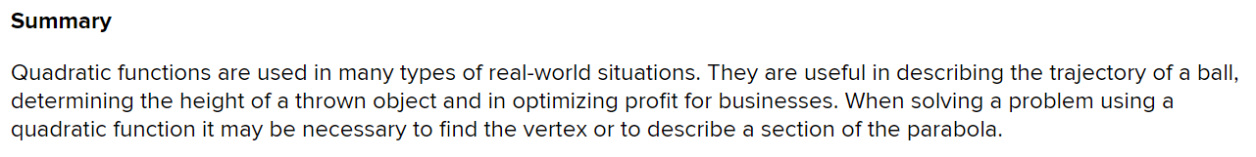

Title: ________________________________________________________________

1 to 3 sentence summary of the article:

Practice
