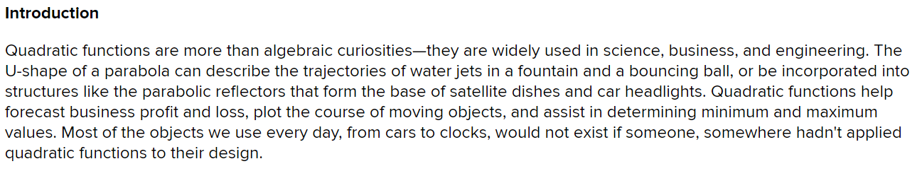
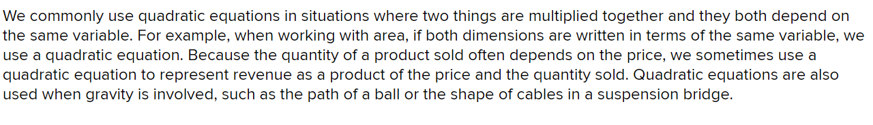
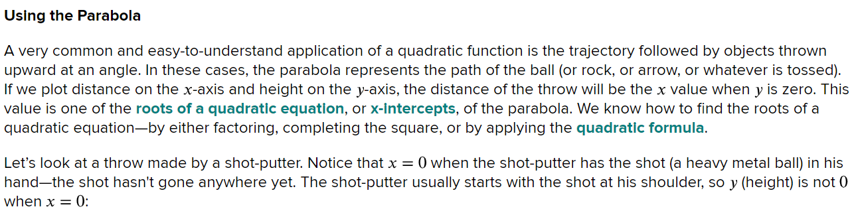
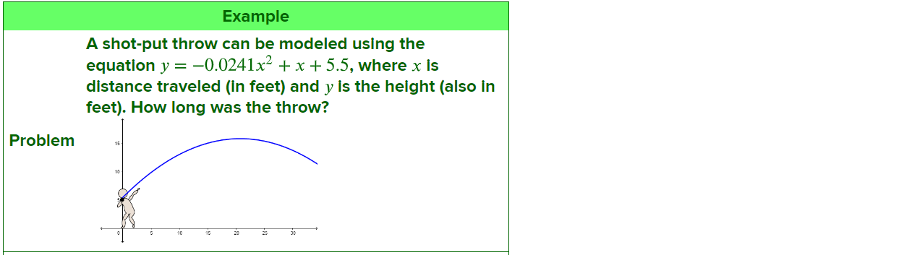
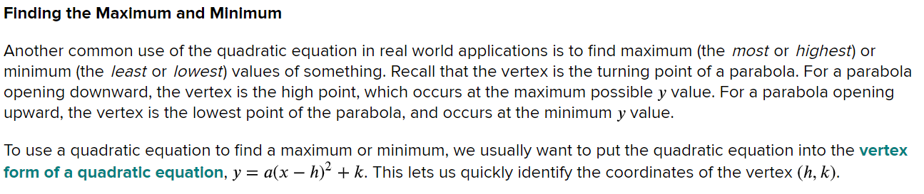
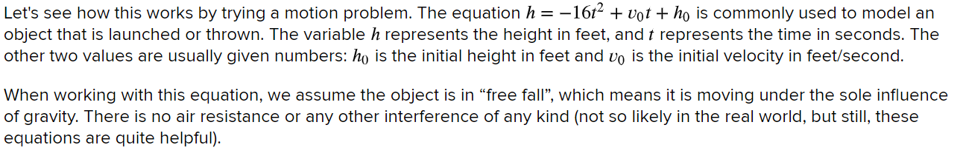
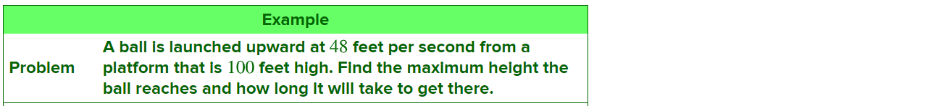
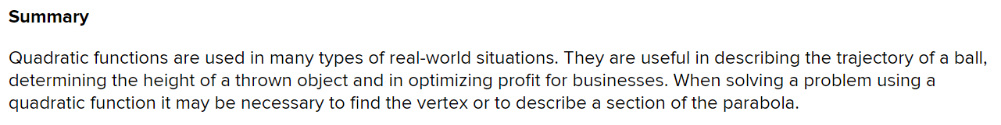

Title: ________________________________________________________________

1 to 3 sentence summary of the article:

Practice
