New vocabulary
Complex number i = a unique number defined as the square root of -1. It's a key part of complex numbers, which are in the form a + bi. Also called an ‘imaginary number.’
Arbitrary = based on random choice or personal whim, rather than any reason or system
Actuality = existing conditions or facts
Tangible = can be touched.
Visualized = form a mental image of; imagine
Intuitive = using or based on what one feels to be true even without conscious reasoning; instinctive.
Obvious = easily perceived or understood; clear.

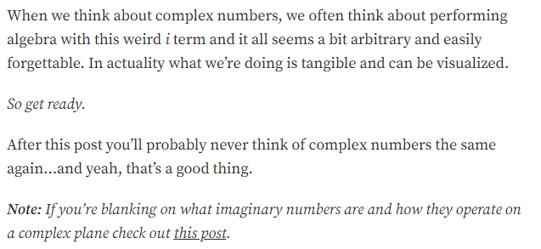
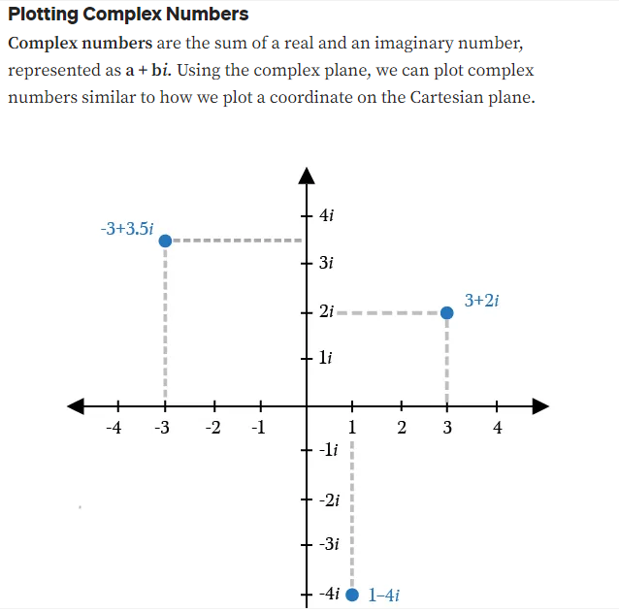
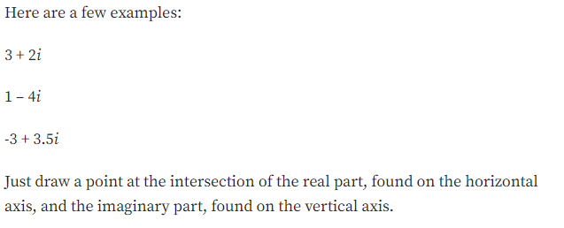
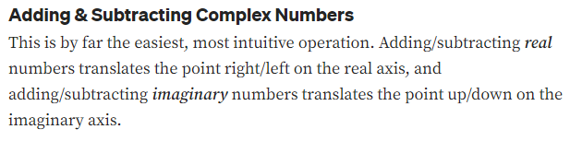
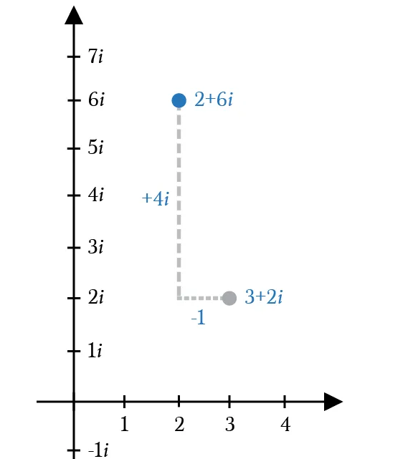
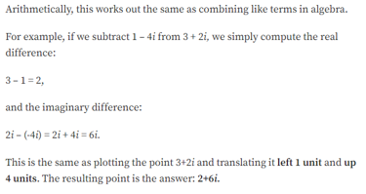

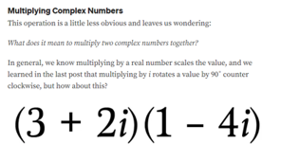
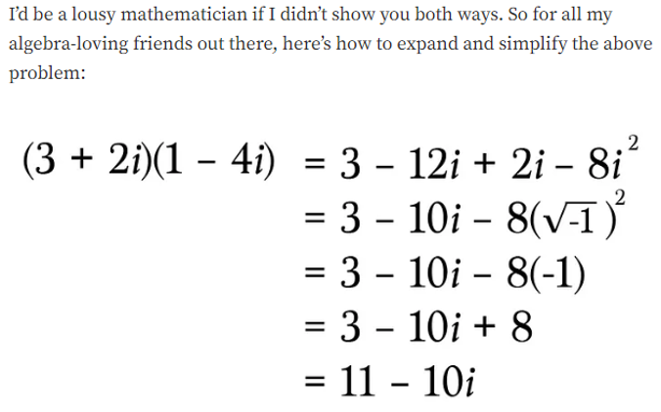

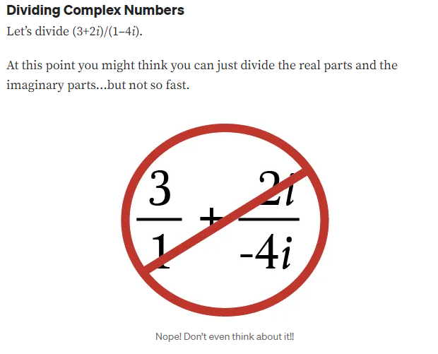
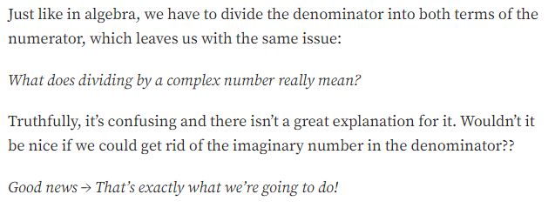
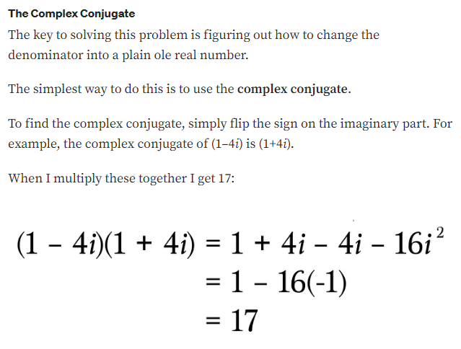
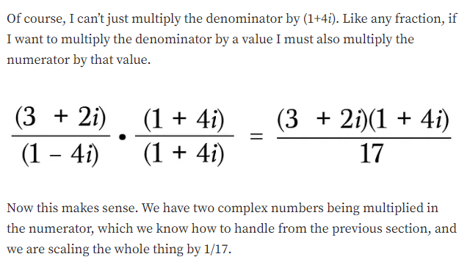
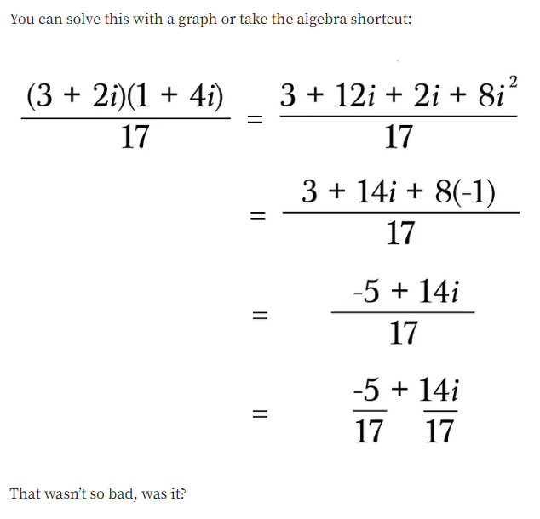

Title: ________________________________________________________________

1 to 3 sentence summary of the article:

Try these problems with complex numbers.
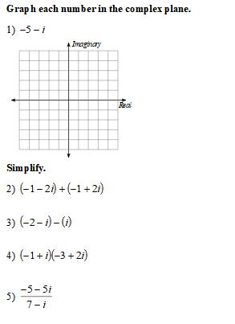
6) Find the complex conjugate of the following.
