Simplify.

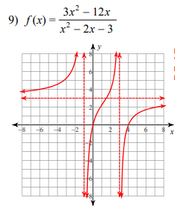

State the EB for the rational function.
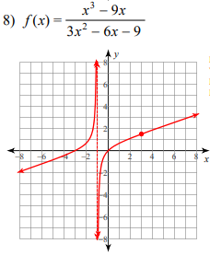

Solve the rational equation.
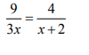
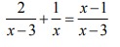
3) 4)

