Find the EB of the following:
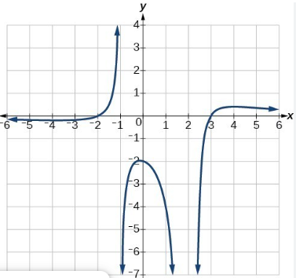
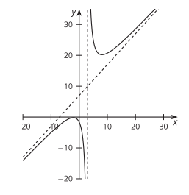

EB is not always infinite or negative infinity…now that we have rational functions.

Identity the EB for 2 of the following graphs.
