Vocabulary

Rational Function Numerator Denominator

Polynomial Quotient



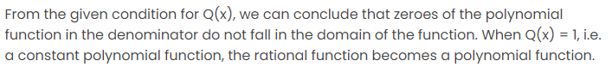

Title: ________________________________________________________________

1 to 3 sentence summary of the article:

