Opening
End behavior
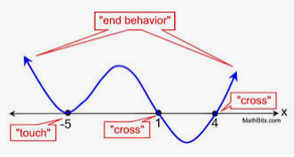

In your own words be prepared to discuss what you think ‘end behavior’ is.

Closing
Use appropriate notation to write the end behavior for the following 2 graphs.
