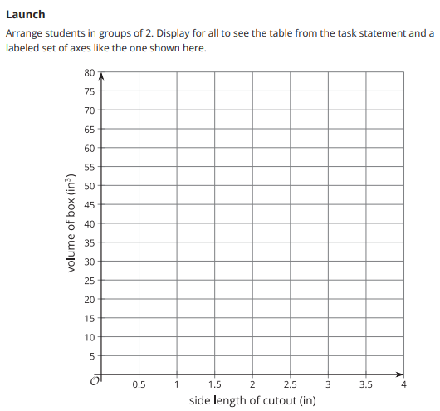

Your side length of cut out is 0.5

Your side length of cut out is 1.0

Your side length of cut out is 1.5

Your side length of cut out is 2.0

Your side length of cut out is 2.5

Your side length of cut out is 3.0

Your side length of cut out is 3.5

Your side length of cut out is 4.0

Your side length of cut out is 0.5

Your side length of cut out is 1.0

Your side length of cut out is 1.5

Your side length of cut out is 2.0

Your side length of cut out is 2.5

Your side length of cut out is 3.0

Your side length of cut out is 3.5

Your side length of cut out is 4.0

Your side length of cut out is 0.5

Your side length of cut out is 1.0

Your side length of cut out is 1.5

Your side length of cut out is 2.0

Your side length of cut out is 2.5

Your side length of cut out is 3.0

Your side length of cut out is 3.5

Your side length of cut out is 4.0

Your side length of cut out is 0.5

Your side length of cut out is 1.0

Your side length of cut out is 1.5

Your side length of cut out is 2.0

Your side length of cut out is 2.5

Your side length of cut out is 3.0

