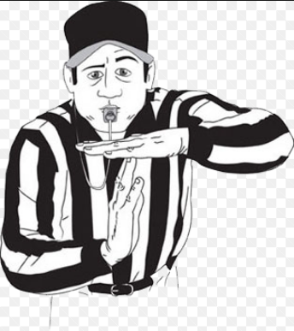

When timeout is called by Mrs. Cole:

Everyone will immediately make the timeout signal using both hands
Stop talking
Thank you!
You can call a foul for something which is said or done to you, or to someone else:

A foul is a comment or action which hurts someone’s feelings.
If you call a foul, you must be able to state what was said or done by the person who fouled
The fouled person owes someone 2 affirmations!
Affirmations starters (if you need help):

You did a good job of…
I am glad that you…
I admire you for…
I like how you...
Thank you for…
I can tell you are really trying hard at…
You are really good at…
Way to go for….
That was a great way to…
Nice work showing…
…or you can create your own affirmations to the person you fouled.
If you are not on-task….be on the lookout for the ‘thumbs-up’ notification from a classmate:

If your classmate gives you this ‘thumbs-ups’ signal, this is a reminder for you to stop your behavior that is interfering with learning and get back on task!

