Name ______________________ Your math teacher______________ My checklist!
Unit 1
Operations with Rational Numbers
_______ Video: https://www.youtube.com/watch?reload=9&v=4e2PY-xY2fE
_______ Paper
_______ Online: https://quizizz.com/join/game/U2FsdGVkX18uzvQJXaqXjAM7GMA0NVARex2srB1qdR2AY9JiGW9ej3kthYWl%252B3bV?gameType=solo
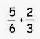
Wrap-up:
=
Unit 2
Expressions & Equations/inequalities
_______ Video: https://www.youtube.com/watch?v=ov10JnyN8Mo
_______ Paper
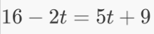
_______ Online: http://www.math-play.com/Inequality-Game.html
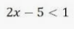
Wrap-up

Unit 3
Ratios and Proportional Relationships
_______ Video: https://us.sofatutor.com/mathematics/videos/ratio-and-proportions or https://study.com/academy/lesson/how-to-solve-ratio-word-problems.html
_______ Paper
_______ Online: https://highered.mheducation.com/sites/007092242x/student_view0/get_ready_for_grade_912/ratio_and_proportion_quiz.html
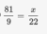
_______ Wrap-up 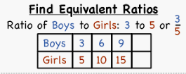

& then there was the …
________ Substitution Challenge

Unit 1 Name __________________________
Operations with Rational Numbers
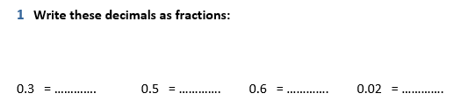
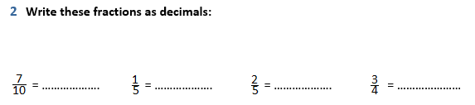

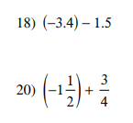

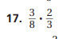
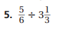

Unit 2 Name __________________________
Expressions & Equations/inequalities
Solve ONE column!!

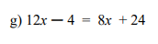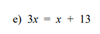

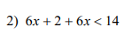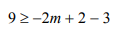

Unit 3 Name __________________________
Ratios and Proportional Relationships

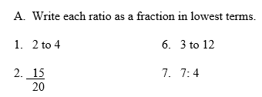

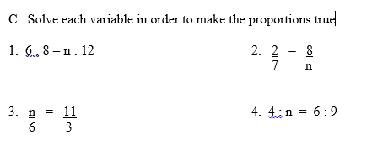

∞Substitution Challenge Name __________________________
Find a friend & solve these!!
