Course Description: The Georgia Department of Education prepares students for 21st century workplace careers by providing high quality educational opportunities in sciences, technology, engineering and mathematics fields (STEM).
Grading Policy: Students will be given various activities to demonstrate their mastery and understanding of STEM content and projects.
Attendance: Attendance strongly correlates to success in school. Please make sure students regularly attend school for success in all their courses.
Required Materials: Please make sure students have paper and pencils each day. A binder will be useful for students to organize their course materials, and is requested.
Communication: Students should feel free to communicate with me at any time. If parents need to reach out, please do so at the above contact information. I use REMIND to reach parents and students concerning activities related to the course. Using a smartphone please text the following, depending on your class, to receive messages:
6th - 7th -
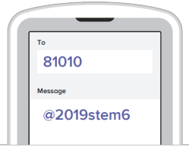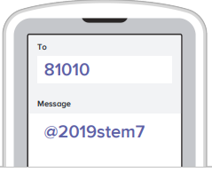
If you or your student do not have a smartphone, the same information will be available to the students in class. Also, I have a class website which will be updated regularly, mrscolelovesmath.weebly.com. Please visit the website as your student will be using the website regularly.
I look forward to working with each student in order to reach their success! Go Eagles!!

