Mrs. Lyn Cole
Courses: Collaborative 7th and 8th grade Maths with Mr. Fussell
& STEM
Contact information:
lyn.johnsoncole@carrollcountyschools.com or 770.834.3389
Website: mrscolelovesmath.weebly.com
Remind:
5th period
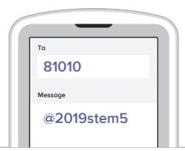
6th period
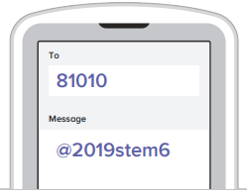
Mrs. Lyn Cole
Courses: Collaborative 7th and 8th grade Maths with Mr. Fussell
& STEM
Contact information:
lyn.johnsoncole@carrollcountyschools.com or 770.834.3389
Website: mrscolelovesmath.weebly.com
Remind:
5th period
6th period
Mrs. Lyn Cole
Courses: Collaborative 7th and 8th grade Maths with Mr. Fussell
& STEM
Contact information:
lyn.johnsoncole@carrollcountyschools.com or 770.834.3389
Website: mrscolelovesmath.weebly.com
Remind:
5th period
6th period

