Read this document thoroughly before you begin this project!
You will be working with a team of your peers. Please be willing to share your ideas and concerns with your team as you work toward the goal of constructing a structure with the materials provided.
1 piece of cardboard
2 rubber bands & 2 piece of paper
3 straws
4 pieces of tape
5 paper clips
You will present your structure to the rest of your class at the end of a specified time.
The goal of this project will be to make the highest structure with your materials. I will be using a ruler to measure your team’s work.
I look forward to see your creations!!

After each team presents you will answer the following questions, individually, on notebook paper. You will not work on answering these questions during presentations of other teams’ structures.
1) What did your team do well?
2) What can your team improve on?
3) What material was most useful to contribute to the height of your structure? Explain why.
4) What material was not useful to contribute to the height of your structure? Explain why.
5) After viewing all teams’ work what would you do differently to make your structure higher?

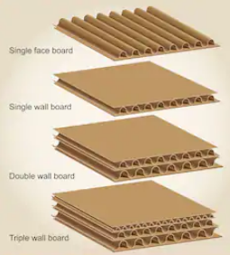
Think about this…Look at the different types of cardboard designs…have you seen others??

