Please read the entire document before you start.
BEFORE you submit your game, please make sure you have ‘shared’ your game in Scratch to make it public and emailed it to me. When I receive your url, I will place your game on the class website. 6th and 7th period STEM students will review your game.
*Don’t limit your review to STEM students at MZM. Share your game with your brothers, sisters, mom, dad, uncle, grandma, cousin, etc. Get their option and see if there is something they suggest to change!!
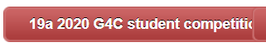
When your game is ready, we will be doing the following to submit by the due date 3/31/2020!
The complete details can be found on the following document:

The most important information is pasted below:
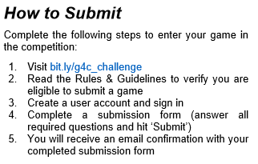

When you submit your game, send me a screen capture…this must take place by…
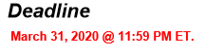

Yay! You made it! Best of luck on winning in your category!

