Please read the entire document before you start.
Part 1: Today you will be summarizing what you learned in the ‘Create an original serious game’ phase of our G4C project. This phase is screen captured below:
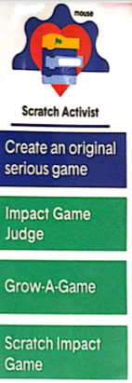
You will be obtaining urls from different people in the class of their scratch game. (Get them to email you their url in order to avoid typing errors!) Please play their game several times be sure to include what you like (minimum of 3 things) and what you would change (minimum of 3 thing) and include me on your return email to them. For example:
Coach Cole sends me an email of his scratch game:
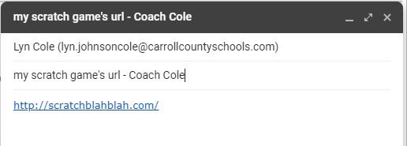
I copy and paste his game’s url into my browser and play his game for about 4 minutes. After I play his game, I want to provide my feedback in a return email to him and copy Mrs. Cole (notice I used the cc: to copy Mrs. Cole. You will do this for each students’ game you provide feedback to.
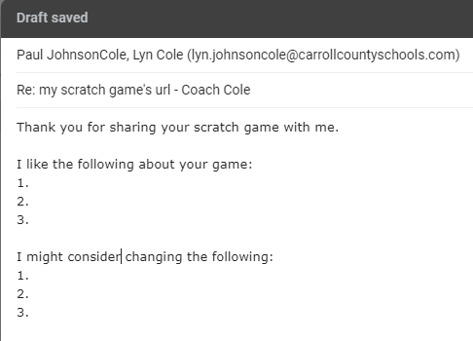
Do you have to make every change shared by your peers? No, these are suggestions for you to consider, if they really do improve your game. If you do not understand someone’s suggestion, please ask them for clarification.
You will do this for 3 different (I will assign students – so everyone’s game can be reviewed) students! Please do not forget to ‘cc’ Mrs. Cole

Part 2:
You are going to apply the five game vocabulary words to your scratch game. Please recall the following:
Space: Where does the game take place?
Goal: How do you win?
Components: What are all the ‘pieces’ necessary to play?
Core Mechanics: What actions are you constantly repeating?
Rules: What can or can’t you do in the game? What are the boundaries?

For each of the 5 vocabulary words you will describe in 2 to 3 complete sentences the vocabulary word related to your scratch game. Your responses must be written in complete sentences with proper punctuation! Please complete this on a sheet of paper and hand this in.

Part3:
Now to test your knowledge of ‘create an original serious game’ with a quiz.
Please click on the following url. This will take you to an assessment of your knowledge of the Scratch Activist phase in the G4C challenge.
https://forms.gle/tjvAVN5LkPeYdpgR8
If the above like does not work, please copy and paste the link (using Crtl+C and Crtl+V)
I look forward to seeing what you have learned during the Scratch Activist phase!

