Please read the entire document before you start.
You are entering the final phase of the G4C challenge!
Before starting make sure you have completed all steps in the 2nd phase, Scratch Developer, these include all activities from our class website below:
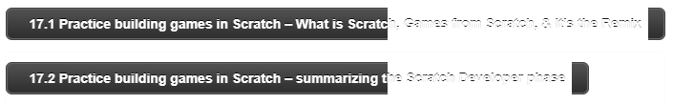
There are several things you should have submitted along the way in mouse.org (17.1) and some activities summarizing your working (17.2). All of these must be submitted, as they will count for a grade!

The 3rd and final phase of the G4C challenge is Scratch Activist! You have learned many skills in the activities from mouse.org in order to design a game for change (a clean and happy earth, how the human-animal bond benefits people and pets, inclusive play: Designing games for all). Work through the following activities (please take your time in order to design a winning game!) and turn in the required work along the way.

These are the activities from the poster you will complete in this phase:
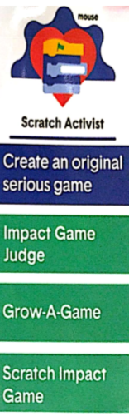
Where is your emoji?? Is your emoji where it should be based on your progress?? If so, yay! If not, please move your emoji!
Please complete the following steps in mouse.org and submit the required work along the way. Please ask a neighbor or me for help, if you need help!
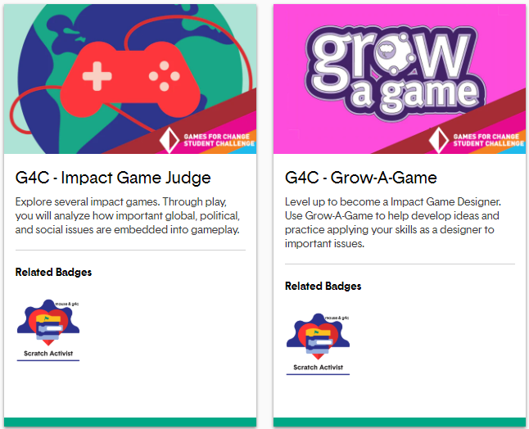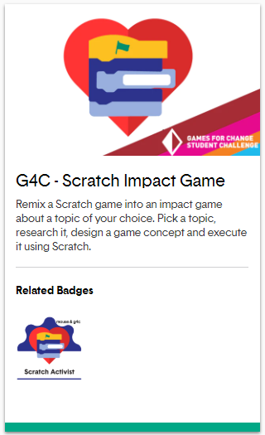
The above activities will be complete before you submit your final product! Please DO NOT submit your final product until I (and several class peers) have a chance to play your game. This way you will get good feedback for an even better game!!
Good luck on phase 3!

