Please read the entire document before you start.
Part 1: Today you will be summarizing what you learned in the ‘Practice building games in Scratch’ phase of our G4C project. This phase is screen captured below:
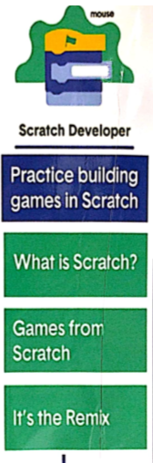
You may work with, at most, two other people (if they are not at your assigned table, you must have approval before you start. You will need to get a white board and marker and for each of the three topics under “Practice building games in Scratch,” you will state two things from each topic you learned. Each person will take time working on ideas and presenting on flipgrid.
This is the code to access flipgrid:
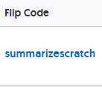
Part 2:
You also will go to scratch and click on explore
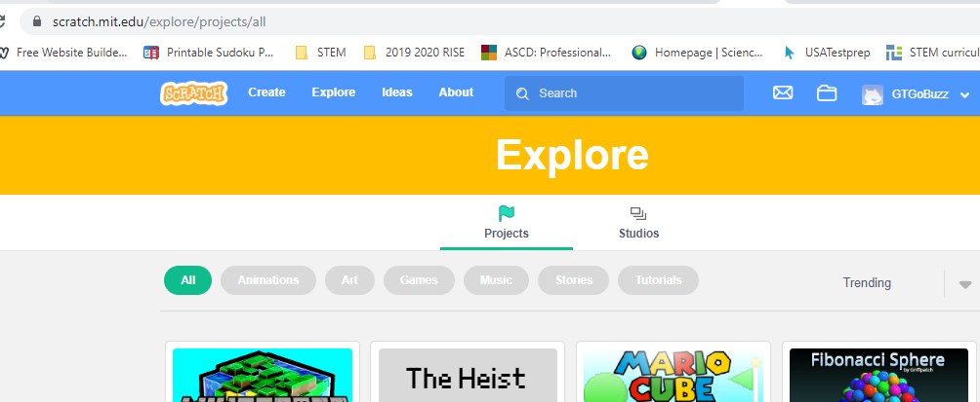
You will find three games to practice. You will screen capture the game and list 3 things you would change, if you where the scratch programmer. Please submit this by email. The title of your email will be your period, last name and summarizing part 2.
An example title would be: 6th Cole – summarizing part 2
Your responses must be written in complete sentences with proper punctuation!
Part3:
Now to test your knowledge of game design with a quiz.
Please click on the following url. This will take you to an assessment of your knowledge of the Scratch Developer phase in the G4C challenge.
https://forms.gle/3MZcF61c6dzD3gVQ8
If the above like does not work, please copy and paste the link (using Crtl+C and Crtl+V)
I look forward to seeing what you have learned during the Game Design phase!

