Please read the entire document before you start.
You have a little (or maybe more) familiarity with Scratch programming. Today you will start the 2nd phase of the G4C process – Scratch Developer. Before starting make sure you have completed all steps in the 1st phase, Game Designer, these include all activities from our class website below:
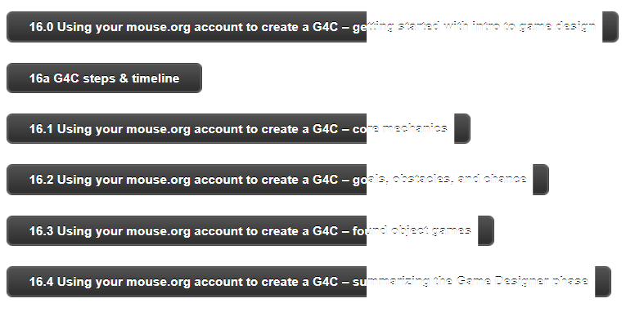
There are several things you should have submitted along the way in mouse.org (16.0 – 16.3) and some activities summarizing your working (16.4). All of these must be submitted, as they will count for a grade!

Today starts Phase 2: Scratch Developer
These are the activities from the poster you will complete in this phase:
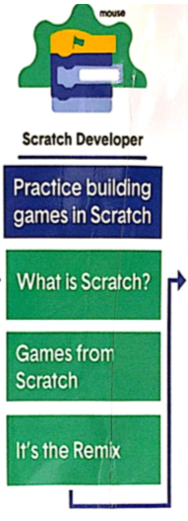
Where is your emoji?? Is your emoji where it should be based on your progress?? If so, yay! If not, please move your emoji!
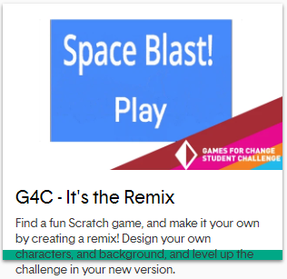
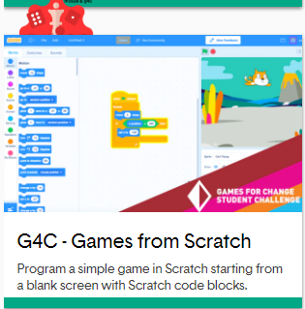
I will not post individual Word documents (as I did in Phase 1). You will log in to mouse.org and complete the following 3 steps with work required in order to complete this phase.
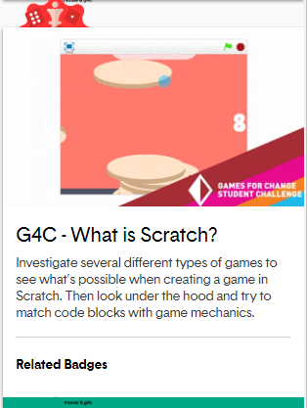

Good luck with building games in Scratch!

