Please read the entire document before you start.
Part 1: Today, you will be writing, talking and sharing ideas. Why? Because that is what Game Designers do!
Please see the following video to discover what a games designer’s work life is like:
https://www.youtube.com/watch?reload=9&v=c0o6BPYKBiA
https://www.youtube.com/watch?v=KcdK6WdqIao
Find a partner! You will view one video; your partner will view the other.
You will make a list of 5 things that are the same between the videos and 5 things that are difference between the video. Finally, you will state if you are interested in Game Design for a career by starting why or why not.
To get you thinking of similarities and differences between the videos:
What was their work setting like?
What objects are around the designers?
How do they start a video?
How are they dressed?
How do they interact with other people?
You will turn this in, please.
Part 2:
You have now finished the Game Designer phase of our project. I want to know what you have learn!
Please write a short paragraph for each of the Game Design topics. You should have 3 paragraphs and each paragraph will have 3-4 sentences. From the poster:
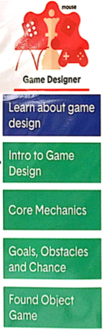
Finish your paragraph with the best thing you discovered about game design.
Part3:
Now to test your knowledge of game design with a quiz.
Please click on the following url. This will take you to an assessment of your knowledge of the Game Design phase in the G4C challenge.
https://forms.gle/FgS3RW3DiT769tEaA
If the above like does not work, please copy and paste the link (using Crtl+C and Crtl+V)
I look forward to seeing what you have learned during the Game Design phase!

