Please read the entire document before you start.
Log in to your mouse.org account.
If you have completed ‘goals, obstacles, and chance’ in mouse.org’s playlist, you should now be ready for the ‘found object game.’
The card looks like this:
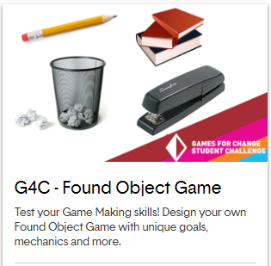
Recall as you are learning about ‘game design,’ you should be thinking about ideas which tie to our 3 topics:
Soon we will take a break with our ‘game design’ phase in order to share our ideas and experiences!

Congratulations on finishing the first phase of our project: Game Design!

