Please read the entire document before you start.
Log in to your mouse.org account. You will want to bookmark this site, as we will use it often.
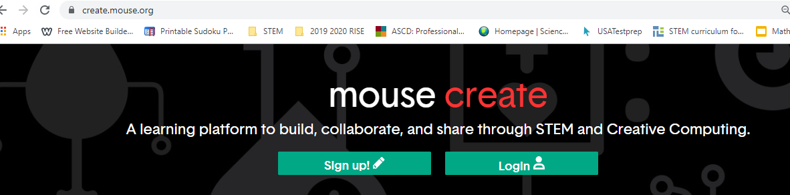
Let’s look in your ‘Playlist.’
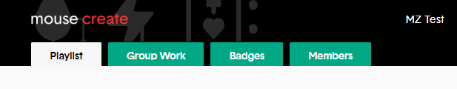
Look at the steps on the poster.
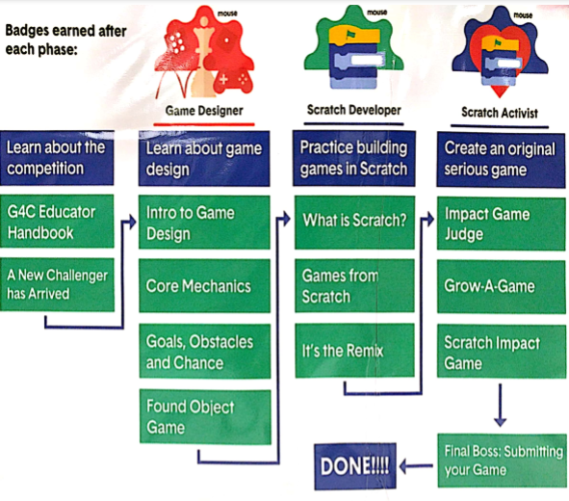
Up next? Now that you have finished ‘Intro to Game Design,’ you will start on ‘Core Mechanics.’
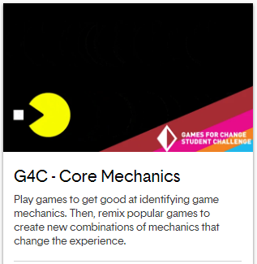
Good luck learning the ‘Core Mechanics’ to video game design! In the last few minutes of class you will need to adjust your emoji, if necessary.

Enjoy learning about the core mechanics of video games!

