Please read the entire document before you start.
Your mouse.org account and the poster on the wall (with your emoji ) are going to keep you on track with the steps we are following to meet the submission date for your final project.
Mouse.org has given you, as a game designer, steps to ensure you are able to create a G4C submission, even if you have no prior game design or programming experience. As you complete the steps following the poster on the wall, you will gain the skills you need to create a game using game design. Based on your prior experiences with computers, game play, and other factors you may progress more quickly or more slowly on some steps in the game design process. Do not worry! Take your time and learn the skills so you can develop the best game possible!
Review the video at https://create.mouse.org/. The video is immediately under the login.
Log in to your mouse.org account. You will want to bookmark this site, as we will use it often.
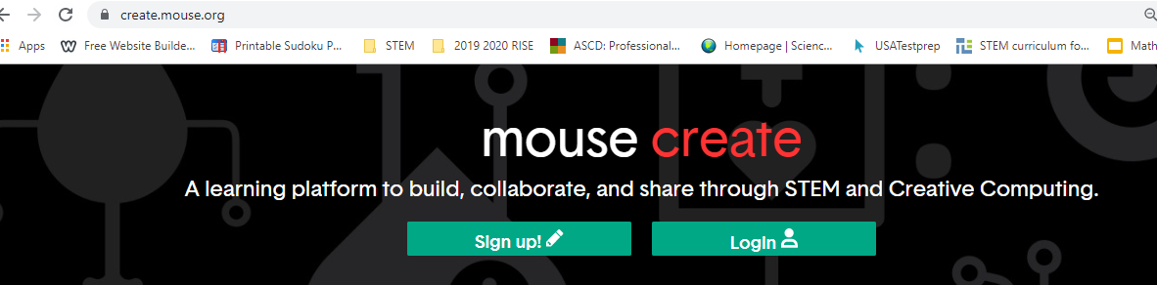
Let’s get started on the first step. Look at your ‘Playlist.’
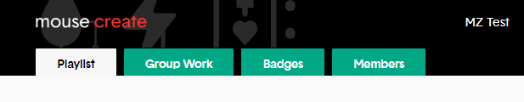
Look at the steps on the poster.
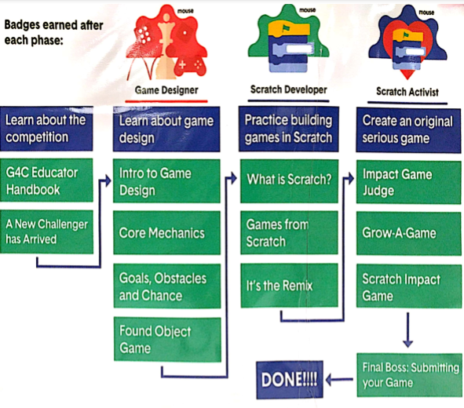
Where do you start? You are going to start by learning about game design (the very left column on the poster are my activities).
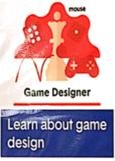
Therefore, you are going to start with ‘Intro to Game Deisgn.’
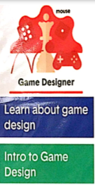
Now go to mouse.org playlist and find that activity…click on that activity and get started!
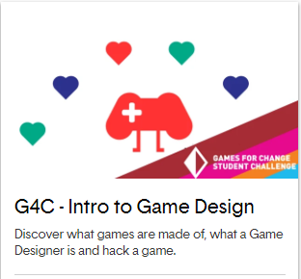
In the last few minutes of class, will you move your emoji on the poster?? Did you complete this activity and are ready to start on the next activity tomorrow, or are you going to continue to work on this activity tomorrow?
Remember the goal is not to rush through the work, it is to learn everything mouse.org is teaching you in order to create a great G4C!

I hope you enjoy game design!

