Please read the entire document. Write the paragraph on your own paper. Write in complete sentences using proper punctuation.
You will select one of the three topics below (a clean & happy earth, now the human-animal bond benefits people and pets, or inclusive play: designing games for all).
You will use your Chromebook to research your selected topic…
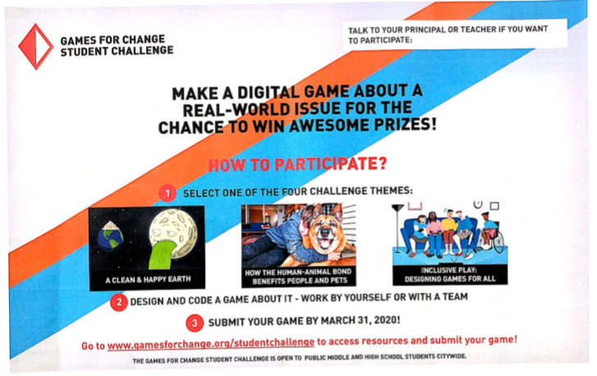
Please hand write, using complete sentences, a paragraph which includes, but is not limited to the following about your topic. Your paragraph will have a minimum of 10 sentences.
- Why did you choose this topic?
- What about this topic interests you?
- What do you currently know about the topic (prior to any laptop research)?
- Write about several facts you learned while completing your research.
- Why is this topic important?
- What is the most important thing about this topic?
- Who is one other person who picked the topic you picked?

If time permits, share your paragraph with someone at your table and allow them to give you feedback. Please turn your work in. This is a grade.

If none of the topics interest, you please write about topic #1. Thank you!

I look forward to receiving your paragraph! Happy researching!!

P.S. If you need a reminder on how to write a paragraph, please see the following organizer.
