Please read entire document before your team starts!
Today you will grow-a-game. The directions for grow-a-game are as follows.
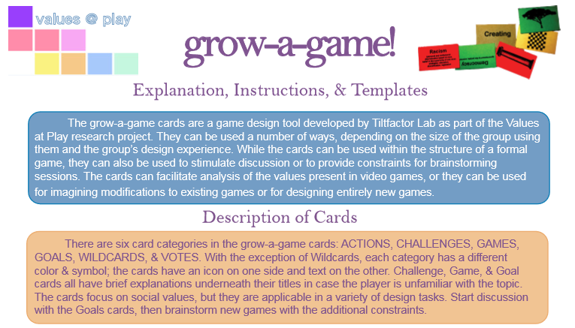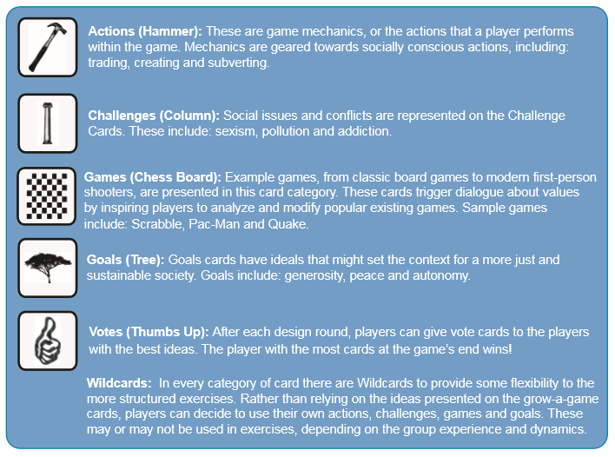
Please view the short video on https://tiltfactor.org/. What is different about tiltfactor’s games?
For teacher:
