Please read the following instructions completely before starting! We will be discussing all answers to questions within this document, therefore you are expected to participate and ask questions.

Today we will begin to look at scratch block programming. When you sign up for an account in my scratch classroom, you will have a screen like this:
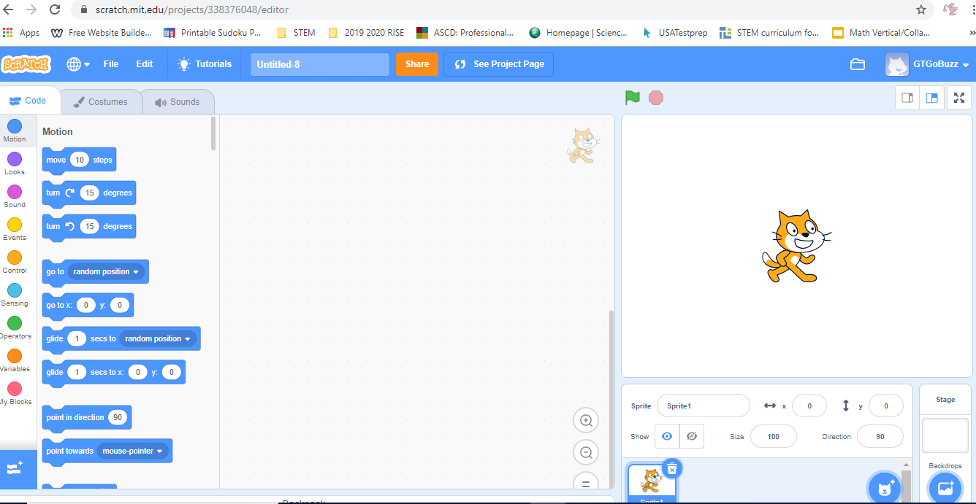
Notice 3 important parts of the scratch screen, the left, the middle, and the right.

On the left you can toggle be buttons. What do the buttons do?

In the middle, this is where you will write your code by dragging and dropping the code from the left. What does the code do?

On the right, your code will be executed using your selected Sprite. What is a Sprite? Who is the current Sprite?

What things do you notice below the Sprite? What is the stage?

We are about to start programming!

